Senior Leadership Team (SLT) - Quality, Safety and Governance
17 April 2025

Paper title: | Learning from deaths |  |  | Agenda  Item  XX
Presented by: | Dr David Sims, Medical Director |  |  | Agenda  Item  XX
Prepared by: | Sallie Turner, Mortality & Duty of Candour Improvement Facilitator  Rachel Howitt, Head of Patient Safety/Patient Safety Specialist |  |  | Agenda  Item  XX
Committees where content has been discussed previously |  | n/a
Purpose of the paper  Please check ONE box only: |  | ☐ For approval  ☐ For discussion | ☒ For information

Relationship to the Strategic priorities and Board Assurance Framework (BAF)
The work contained with this report contributes to the delivery of the following themes within the BAF
Being the Best Place to Work | Looking after our people
Being the Best Place to Work | Belonging to our organisation
Being the Best Place to Work | New ways of working and delivering care
Being the Best Place to Work | Growing for the future
Delivering Best Quality Services | Improving Access and Flow
Delivering Best Quality Services | Learning for Improvement | √
Delivering Best Quality Services | Improving the experience of people who use our services | √
Making Best Use of Resources | Financial sustainability
Making Best Use of Resources | Our environment and workplace
Making Best Use of Resources | Giving back to our communities
Being the Best Partner | Partnership
Good governance | Governance, accountability & oversight | √

Purpose of the report
The purpose of this report it to provide Board with an overview of the learning the Trust has taken from the deaths of patients within its care during Q4, 2024/25.

Executive Summary
Learning from deaths is supported by two key policies in Bradford District Care Foundation Trust (BDCFT), the Patient Safety Incident Response Policy (PSIRP) and the Learning from Deaths (LfD) Policy. These policies guide and inform the organisation about reporting, investigating and learning from deaths. Between 01 January 2025 and 31 March 2025 there have been 69 deaths reported. This is consistent with the same period the previous year.

1 Patient Safety Incident Investigation (PSII) report has been completed. 1 Structured Judgement Review (SJR) commissioned by the Patient Safety Executive Panel (PSEP) has also been completed.

Learning from excellence and learning for improvement was identified in all cases and continues to be shared with teams and across the organisation.
Do the recommendations in this paper have any impact upon the requirements of the protected groups identified by the Equality Act? | ☐ Yes (please set out in your paper what action has been taken to address this)  ☒ No

Recommendation(s)
The SLT - Quality, Safety and Governance group is asked to:

- Note the content of the report and take assurance that our processes for reviewing and learning from deaths is robust and appropriate

Links to the Strategic Organisational Risk register (SORR) | The work contained with this report links to the following corporate risks as identified in the SORR:  - n/a
Care Quality Commission domains  Please check ALL that apply | ☒ Safe  ☐ Effective  ☒ Responsive | ☒ Caring  ☒ Well-Led
Compliance & regulatory implications | The following compliance and regulatory implications have been identified as a result of the work outlined in this report:  - n/a

SLT - Quality, Safety and Governance
17 April 2025

Learning from Deaths 2024/2025 Q4

Introduction and background
Learning from deaths is supported by two key policies in BDCFT; the Patient Safety Incident Response Policy (PSIRP) and the Learning from Deaths (LfD) Policy. These policies guide and inform the organisation about reporting, investigating and learning from deaths.
Current Status
Between 01 January 2025 and 31 March 2025, a total of 69 of Bradford District Care NHS Foundation Trust’s patients died. There were 74 in Q4 last year.
During Q4 there were 9 reported deaths of a Service User with a registered Learning Disability and/or a clinical diagnosis of Autism. These have undergone Learning for Lives and Deaths (LeDeR) service improvement reviews.
Table 1: Number of reported patient deaths per quarter (rolling 12 months)
 | Quarter 1  24/25 | Quarter 2  24/25 | Quarter 3  24/25 | Quarter 4  24/25
Number of patients who have died during previous 12 months | April – 28  May – 25  June - 31 | Jul – 20  Aug – 22  Sept – 23 | Oct - 22  Nov - 31  Dec - 41 | Jan – 33  Feb – 18  Mar - 18
Total per quarter | 84 | 65 | 94 | 69
Total number of patients who have died in the last 4 quarters | 312

To note: the total numbers presented per quarter in this report may be slightly different if compared directly to previous reports. This is due in part to the data cleansing process, and also due to variance at the time of data extraction for the reporting period. This slight variance is created by some deaths not being included in a quarters data at the time of developing the report, because the Trust was notified and/or the death was reported in a later quarter. The data was correct at the time of report development and has now been adjusted to reflect an accurate account at year end.
All deaths, whether expected due to a clinical condition or unexpected, are reviewed bi-weekly in the Patient Safety Executive Panel (PSEP) which aligns with good governance processes under the Patient Safety Incident Response Framework (PSIRF) requirements which commenced in April 2024.
This group commissions reviews of case notes from a sample of deaths using the Structured Judgment Review (SJR) tool. This is a national tool developed by the Royal College of Psychiatrists to allow clinicians to take an expert view of the care offered. The Group may also commission initial reviews which do not consider the full range of factors within the SJR review to understand if an SJR is appropriate, or where an SJR is not required but where there may be learning, other review methods may be used for example a Local Learning
Review (LLR), After Action Review (AAR) or Thematic Analysis (TA) to identifying learning in order to minimise the risk of future harm.

The Patient Safety Executive Panel considers the outcomes of the reviews and asks the relevant Quality and Operational (QuOPs) meeting to develop an action plan in regard to any areas where it has been suggested that care should be improved. Issues that are of general relevance will be added to the trust Patient Safety and Learning page to enable broader sharing across the organisation. For all deaths of patients who have a Learning Disability, the initial review is shared in the Patient Safety Executive Panel and they are referred to the national Learning for Lives and Deaths (LeDeR) programme.
The Mortality screening tool, embedded on Safeguard, continues to enable reporters to provide more complete information regarding deaths at an earlier point. This is helping facilitate the decisions at PSEP regarding level of review/investigation required.
The number of deaths in each quarter for which a Review, Thematic Analysis or Patient Safety Incident Investigation (PSII) was carried out are shown in the following table:
 | Quarter 1  24/25 | Quarter 2  24/25 | Quarter 3  24/25 | Quarter 4  24/25
Number of deaths for which a Structured Judgement Review was completed | 5* | 5 | 1 | 1
Number of deaths for which a Local Learning Review was completed | *Not previously broken down by type, figures included in the above* | 3 | 2 | 0
Number of deaths for which an After Action Review was completed |  | 0 | 0 | 0
Number of deaths which were included in a completed Thematic Analysis |  |  | 10 | 0
Number of deaths for which a PSII was completed | 3 | 5 | 6 | 1
Number of deaths of persons with learning disabilities or Autism, referred for local LeDeR review. | 6 | 2 | 9 | 9

Please note:
1 SJR monitored via the patient safety process was a death that occurred in the Q4 2023/24 period and the review was completed in Q4 2024/25. A delay in allocation impacted the timescale for completion.
2 SJRs monitored via PSEP and commissioned in previous reporting periods are now overdue.
1 PSII investigation was for a death that occurred in the previous reporting periods and the investigations were completed in this reporting period (Q4 24/25).
All types of incident response (PSII, SJR, TA, LLR or AAR) have the same remit of identifying system learning for improvement.
Learning and improvement
BDCFT takes a proactive approach to learning from deaths and the following summary highlights where good practice and areas identified for improvement have been highlighted during Q4, 2024/25. This learning is used to shape future quality and safety improvements.
Learning from good and excellence:
A number of reviews were conducted that concluded good and excellent care had been provided by various inpatient and community teams. The aspects of care identified as demonstrating this were:
- The recommendations from WY Fire & Rescue Service (WYFRS) have already been addressed and an action plan/response have been completed.
- AOT did really good work in engaging the patient from the point they got involved in his care.
- He was supported with his accommodation soon after discharge from Lynfield Mount Hospital (LMH), he was supported to move to more independent living.
- Assertive Outreach Team (AOT) were responsive to his needs, they attended quickly when there was a crisis, they linked in with his mother and his housing workers, they helped him get to his appointments including those for his physical health, they were sensitive and attentive when he was in crisis and kept a close watch on him and his risk around that time.
- They enabled him to become more confident and function better socially.
- Even though he didn’t really engage he was looked after until there was accommodation identified that he could be safely discharged to.
- The patient received compassionate, considered, holistic and good quality care.
- Given that most of his issues were related to substance misuse, staff brought a broader look of the overall picture into consideration, which has to be commended.
- They supported him in every way possible and referred him to AOT when they realised his needs could not be met through the Community Mental Health Team (CMHT).
- The team helped to facilitate contact with his mother when she was ill, and his sister when he needed it.
- They showed good collaboration with his housing workers. They were quick to respond when there was a crisis.
- The patient was difficult to engage with but at the time of his death the positive changes he had made in every aspect of his life and functioning were nothing short of remarkable and the recovery focussed approach through AOT was instrumental in this.

Learning for improvement:
Some learning was identified from a number of reviews where care had not gone so well, and improvements could be made. An action plan is developed for all events where learning is identified and is monitored through the operational quality improvement processes in the Trust, with oversight via QuOps structures and in the Patient Safety and Learning Group (PSLG). Examples of the learning identified relate to:
- Care was not co-ordinated and the care plan did not represent the patient’s needs and how staff could most effectively support her.
- The risk template including the formulation in place at the time of the incident did not accurately reflect the nature and escalation of the patient’s distress behaviours or the most effective ways to support her.
- A review of ward documentation including safety huddle sheets, handover sheets and observation charts has identified poor documentation and missing information around identified risks.
- Several staff bank members on duty on the night of the incident were out of date with mandatory fire training.
- The Leave of Absence Policy and Search Policy do not reference each other and have strong connections.
- The fire alarm point did not activate outside the patient’s bedroom due to the smoke detector head being tampered with causing no activation of the alarm audio.
- There is confusion around the ward evacuation plan and the plan that was sent to West Yorkshire Fire & Rescue Service (WYFRS).
- Under the Traffic Light System, the Risk Management Plan states, “Nursing staffs to enact additional random checks in addition to general observations” Random checks are not in line with Trust Policy or expected practice and should not be used as part of the management of any service user’s risk.
- Within Safeguard, Incident Reporting (IRE) management review/outcomes state risk logs were updated which was not the case.

Next steps
A number of developments are ongoing to enable the workstreams in relation to mortality to improve and mature.
An annual review and refresh of the Trusts Patient Safety Incident Response Plan (PSIRP) will be undertaken in April 2025 to ensure ongoing responses to patient safety incidents (including deaths) are appropriate, in line with legislation, best practice and guidance and actively promotes and supports a just learning and generative safety culture across the organisation.

Under the LfD Framework with the National Quality Board (NQB) we are required to further review a sample of deaths, that do not fit within the main identified categories, so we can take a broader overview of where learning and improvement is needed. The learning from this sample will be triangulated with other reviews and used to inform improvement.

Expanding the use and development of systems-based PSIRF approaches to incident response, and to support the organisation in ensuring that meaningful learning is identified from reviews, Local Learning Review training is being rolled out during 2025.

BDCFT’s participation in the ‘Northern Alliance’ of mental health trusts is continuing well. Progress has begun with some focussed discussions around developing an online SJR training package and reviewing LfD reporting metrics for better aligning these across the Bradford and Craven Place.
The PSEP group receives a Coroners Learning from Deaths Summary Report on a monthly basis. This provides a summary of national Prevention of Future Death Reports and is also received by the Patient Safety and Learning Group (Insights) to inform triangulation and any safety action required.
In addition, other ongoing developments include:
- Evaluating how assurance is received that appropriate learning has been identified and actions taken as a result in order to minimise the risk of future harm
- Development of reporting content to focus more on improvement activity
- Further refinement to published learning from deaths data in line with the regional and local mortality groups.
Conclusion
For Q4, 2024/25 there has been a 7% decrease on the number of deaths reported compared to the same period last year. There has been a 27% decrease in the number of deaths reported in Q4 of 2024/25 compared to Q3 of 2024/25. This decrease is commonly seen between quarters moving out of the winter period, with last year showing a 24% decrease. The increases are predominantly due to clinical conditions and expected deaths, with unexpected deaths and suicide related deaths remaining low, as shown below:

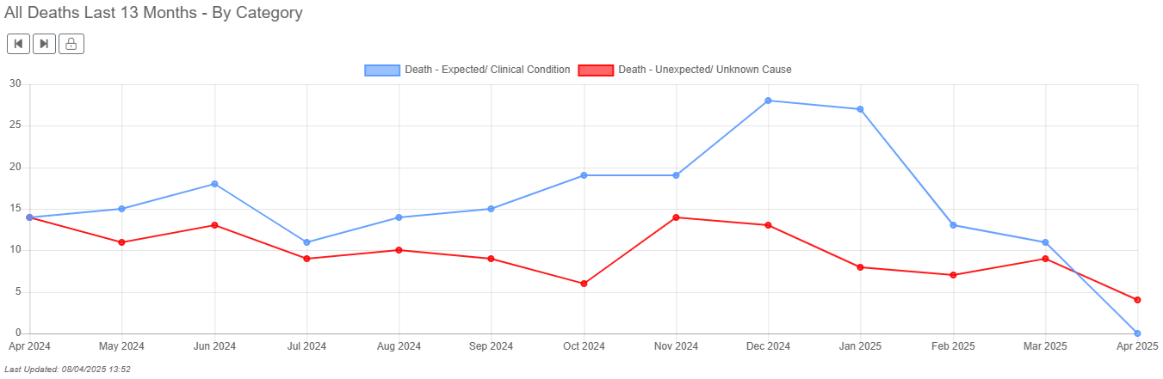

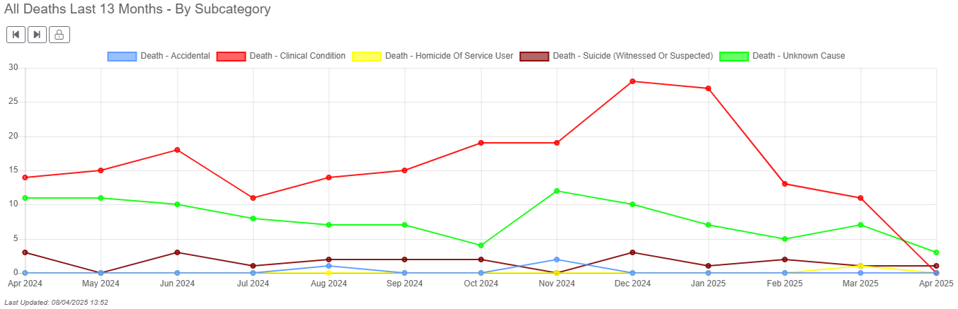

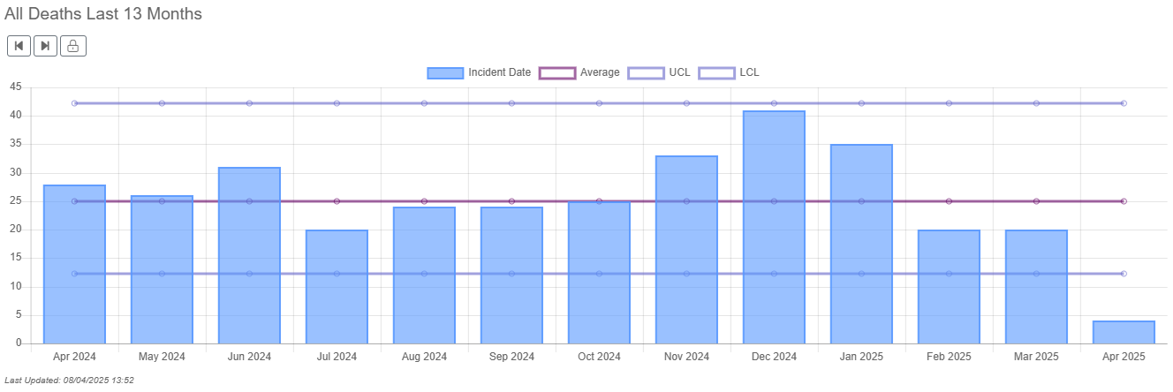
Death under the care of the National Health Service (NHS) is an inevitable outcome for some patients and patients may experience good and excellent care in the months or years leading up to their death. The reporting of deaths and governance arrangements support BDCFT to identify learning where care could be improved and where the good practice can be shared. The reports indicate that the learning required arises from multiple contributory factors, which are system-wide issues and feed into quality improvement activity.

Sallie Turner
Mortality & Duty of Candour Improvement Facilitator

Rachel Howitt
Head of Patient Safety / Patient Safety Specialist
09 April 2025

