Senior Leadership Team (SLT) - Quality, Safety and Governance
21 January 2026

Paper title: | Learning from Deaths - Quarter 3 2025/26 |  |  | Agenda  Item  XX
Presented by: | Dr Sal Uka, Medical Director  Dr Sarfaraz Shora, Deputy Medical Director |  |  | Agenda  Item  XX
Prepared by: | Sallie Turner, Mortality & Duty of Candour Improvement Facilitator  Tricia George, Head of Patient Safety/Patient Safety Specialist |  |  | Agenda  Item  XX
Committees where content has been discussed previously |  | n/a
Purpose of the paper  Please check ONE box only: |  | ☐ For approval  ☐ For discussion | ☒ For information

Relationship to the Strategic priorities and Board Assurance Framework (BAF)
The work contained with this report contributes to the delivery of the following themes within the BAF
Being the Best Place to Work | Looking after our people
Being the Best Place to Work | Belonging to our organisation
Being the Best Place to Work | New ways of working and delivering care
Being the Best Place to Work | Growing for the future
Delivering Best Quality Services | Improving Access and Flow
Delivering Best Quality Services | Learning for Improvement | √
Delivering Best Quality Services | Improving the experience of people who use our services | √
Making Best Use of Resources | Financial sustainability
Making Best Use of Resources | Our environment and workplace
Making Best Use of Resources | Giving back to our communities
Being the Best Partner | Partnership
Good governance | Governance, accountability & oversight | √

Purpose of the report
The purpose of this report it to provide Board with an overview of the learning the Trust has taken from the deaths of patients within its care during Q3, 2025/26.

Executive Summary
Learning from deaths is supported by two key policies in Bradford District Care Foundation Trust (BDCFT), the Patient Safety Incident Response Policy and associated Plan (PSIRP) and the Learning from Deaths (LfD) Policy. These policies guide and inform the organisation about reporting, investigating and learning from deaths. Between 01 October 2025 and 31 December 2025 there have been 100 deaths reported. This is a 6% increase compared with the same period the previous year.

4 Patient Safety Incident Investigation reports have been completed. 0 Structured Judgement Reviews (SJRs) commissioned by the Patient Safety Executive Panel (PSEP) have been completed.

Learning from excellence and learning for improvement were identified in all cases and continues to be shared with teams and across the organisation.
Do the recommendations in this paper have any impact upon the requirements of the protected groups identified by the Equality Act? | ☐ Yes (please set out in your paper what action has been taken to address this)  ☒ No

Recommendation(s)
The SLT - Quality, Safety and Governance group is asked to:

- Note the content of the report and take assurance that our processes for reviewing and learning from deaths is robust and appropriate

Links to the Strategic Organisational Risk register (SORR) | The work contained with this report links to the following corporate risks as identified in the SORR:  - n/a
Care Quality Commission domains  Please check ALL that apply | ☒ Safe  ☐ Effective  ☒ Responsive | ☒ Caring  ☒ Well-Led
Compliance & regulatory implications | The following compliance and regulatory implications have been identified:  - n/a

SLT - Quality, Safety and Governance
21 January 2026

Learning from Deaths 2025/2026 Q3

Introduction and background
Learning from deaths is supported by two key policies in BDCFT; the Patient Safety Incident Response Policy and associated Plan (PSIRP) and the Learning from Deaths (LfD) Policy. These policies guide and inform the organisation about reporting, investigating and learning from deaths.
Current Status
Between 01 October 2025 and 31 December 2025, a total of 100 of Bradford District Care NHS Foundation Trust’s patients died. There were 94 in Q3 last year.
During Q3 there were 4 reported deaths of a Service User with a registered Learning Disability and/or a clinical diagnosis of Autism. These have undergone Learning for Lives and Deaths (LeDeR) service improvement reviews.
Table 1: Number of reported patient deaths per quarter (rolling 18 months)
 | Quarter 3  24/25 | Quarter 4  24/25 | Quarter 1  25/26 | Quarter 2  25/26 | Quarter 3  25/26
Number of patients who have died during previous 12 months | Oct - 22  Nov - 31  Dec - 41 | Jan – 33  Feb – 18  Mar - 18 | April – 20  May – 10  June - 19 | Jul – 22  Aug – 25  Sept – 21 | Oct - 39  Nov - 31  Dec - 30
Total per quarter | 94 | 69 | 49 | 68 | 100
Total number of patients who have died in the last 4 quarters | 380

To note: the total numbers presented per quarter in this report may be slightly different if compared directly to previous reports. This is due in part to the data cleansing process, and due to variance at the time of data extraction for the reporting period. This slight variance is created by some deaths not being included in a quarters data at the time of developing the report, because the Trust was notified and/or the death was reported in a later quarter. Data is correct at the time of report development and will be adjusted to reflect an accurate account at year end.
All deaths, whether expected due to a clinical condition or unexpected, are reviewed bi-weekly in the Patient Safety Executive Panel (PSEP) which aligns with good governance processes under the Patient Safety Incident Response Framework (PSIRF) requirements which commenced in April 2024 and reviewed and approved in June 2025.
This group commissions reviews of case notes from a sample of deaths using the Structured Judgment Review (SJR) tool. This is a national tool developed by the Royal College of Psychiatrists to allow clinicians to take an expert view of the care offered. The Group may also commission initial reviews which do not consider the full range of factors within the SJR review to understand if an SJR is appropriate, or where an SJR is not required but where there may be learning, other review methods may be used; for example a Local Learning Review (LLR), After Action Review (AAR) or Thematic Analysis (TA) to identifying learning in order to minimise the risk of future harm.
The Patient Safety Executive Panel considers the outcomes of the reviews and asks the relevant Quality and Operational (QuOPs) meeting to develop an action plan regarding any areas where it has been suggested that care should be improved. Issues that are of general relevance will be added to the trust Patient Safety and Learning page to enable broader sharing across the organisation. For all deaths of patients who have a Learning Disability, the initial review is shared in the Patient Safety Executive Panel, and they are referred to the national Learning for Lives and Deaths (LeDeR) programme.
The Mortality screening tool, embedded on Safeguard (the Trust’s Local Risk Management System where all deaths are reported), continues to enable reporters to provide more complete information regarding deaths at an earlier point. This is helping facilitate the decisions at PSEP regarding level of review/investigation required.
The number of deaths in each quarter for which a Review, Thematic Analysis or Patient Safety Incident Investigation (PSII) was carried out are shown in the following table:
Table 2: Number of deaths included in completed reviews per quarter (rolling 18 months)
 | Quarter 3  24/25 | Quarter 4  24/25 | Quarter 1  25/26 | Quarter 2  25/26 | Quarter 3  25/26
Number of deaths for which a Structured Judgement Review was completed | 1 | 1 | 5 | 0 | 0
Number of deaths for which a Local Learning Review was completed | 2 | 0 | 1 | 2 | 4
Number of deaths for which an After Action Review was completed | 0 | 0 | 0 | 0 | 0
Number of deaths which were included in a completed Thematic Analysis | 10 | 0 | 4 | 0 | 0
Number of deaths for which a PSII was completed | 6 | 1 | 6 | 4 | 4
Number of deaths of persons with learning disabilities or Autism, referred for local LeDeR review. | 9 | 9 | 3 | 4 | 4

Please note:
4 PSII investigations were for deaths that occurred in the previous reporting periods, and the investigations were completed in this reporting period (Q3 25/26).
4 LLRs were for deaths that occurred in the previous reporting periods, and the investigations were completed in this reporting period (Q3 25/26).
All types of incident response (PSII, SJR, TA, LLR or AAR) have the same remit of identifying system learning for improvement.

Learning and Improvement
BDCFT takes a proactive approach to learning from deaths and the following summary highlights where good practice and areas identified for improvement have been highlighted during Q3, 2025/26. This learning is used to shape future quality and safety improvements.
Learning from good practice and excellence:
Several reviews were conducted that concluded good and excellent care had been provided by various inpatient and community teams.
Some examples of this were:
- Evidence demonstrates that ongoing engagement, collaborative risk assessment, care plans and safety plans were all in place.
- Patient was treated with respect and received good care during interactions with staff and was offered further opportunities to engage with services.
- Mum’s perspective was sought and was involved in discussions about discharge arrangements.
- Perceived risks were effectively managed in relation to expressed suicidal thoughts and actions, and regarding homelessness.
- Staff made reasonable adjustments and gave practical and emotional support to help the patient with communication and accessibility of information.
- The visit identified good practice in terms of a robust assessment being undertaken and evidence of a clear management plan and follow up visit being scheduled.
- A proactive approach was followed in reporting a faulty mattress and a replacement ordered without delay.
- It is assured that the Artificial Intelligence (AI) generated initial referral assessment is effective, however for optimum effectiveness the system depends on referrers giving comprehensive answers.
- Good practice was identified leaving the dressing in place to avoid further trauma.
- Identified risk concerns were communicated with the General Practitioner (GP), and the patient was provided with a safety plan including contact details for crisis services.
- Current Talking Therapies systems support effective transition from self-referral to acceptance onto the appropriate caseload.
- The decision to continue with private sessions and engage with substance use services was the most appropriate pathway aligned with a counselling approach.

Learning for improvement:
Some learning was identified from several reviews where care had not gone so well, and improvements could be made. An action plan is developed for all events where learning is identified and is monitored through the operational quality improvement processes in the Trust, with oversight via QuOps structures and in the Patient Safety and Learning Group (PSLG).
Some examples of the learning identified were:
- Risk was regularly considered, however changes were not captured in the standardised MH assessment format.
- The absence of a Care Coordinator meant that at the time of death the service user’s risk assessment was not up to date.
- Despite contact between the Community Mental Health Team (CMHT) and partner agencies, there was no discussion of joint working initiated by either side, or referral to the Co-occurring Mental Health, Alcohol and Drugs (COMHAD) service which could have facilitated a complex case discussion.
- Risk stratification to predict the likelihood of self-harm/suicide was found to be in use which is not in line with best practice.
- Care was not purposeful or co-ordinated. The care plan did not represent assessed needs or goals, or how staff could most effectively support.
- Discharge and transfer of care was not in line with expected standards, following Care Programme Approach (CPA) guidance, incident reporting and record keeping.
- The patient expressed dissatisfaction at being woken by the visiting nurses.
- A National Early Warning Score (NEWS 2) was not performed and clinical observations not taken, following a patients fall and no reference was made to any other injuries or cause of the fall.
- Patient’s physical health needs were not assessed or care planned in line with expected Trust standards.
- There was not a comprehensive understanding of the patient’s circumstances and risk, to enable safe and effective care planning.
- The patient was allocated to a Preceptee Registered Mental Health Nurse, for care co-ordination, however the required arrangements were not in place to ensure the Preceptee was effectively supervised and supported in their role.
- Despite a plan for discharge from care co-ordination, Patient X was instead added to the waiting list for re-allocation, but contact was not maintained as expected.

Next steps
Several developments are ongoing to enable the workstreams in relation to mortality to improve and mature.
Under the LfD Framework with the National Quality Board (NQB) we are required to further review a sample of deaths, that do not fit within the main identified categories, so we can take a broader overview of where learning and improvement is needed. The sample for the next review is currently underway.

BDCFT’s participation in the ‘Northern Alliance’ of mental health trusts is continuing well. A variety of focussed discussion topics are being scheduled throughout 2026 for trusts to present the learning from their mortality cluster reviews.

Although in the early stages, we have commenced collecting demographic information within our mortality reporting to better understand specific factors (age, gender and race/ethnicity) across services and identify themes to influence mortality insights.
Conclusion
For Q3, 2025/26 there has been a 6% (94) increase on the number of deaths reported compared to the same period last year. There has been a 47% increase in the number of deaths reported in Q3 of 2025/26 compared to Q2 of 2025/2026. This increase is reflective of normal variation and an increase in deaths commonly seen over the winter months. Of the deaths in Q3, 58% were in older people’s services (85% expected and 15% unexpected). The increases are predominantly due to clinical conditions and expected deaths, with unexpected deaths and suicide related deaths remaining low, as shown below:
The main variance within the data represents deaths from clinical conditions, deaths of unknown cause and suspected suicide remain relatively consistent:
Graph 1 – Monthly deaths reported by Category
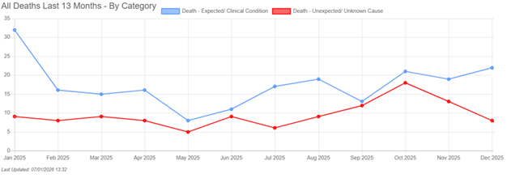
Graph 2 – Monthly deaths reported by Sub-Category
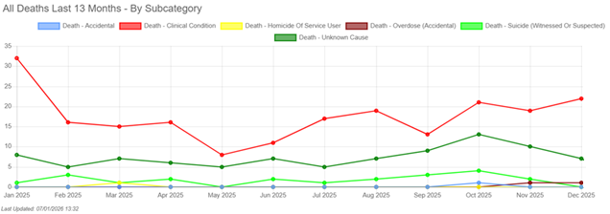
Graph 3 – Number of Deaths reported by Quarter
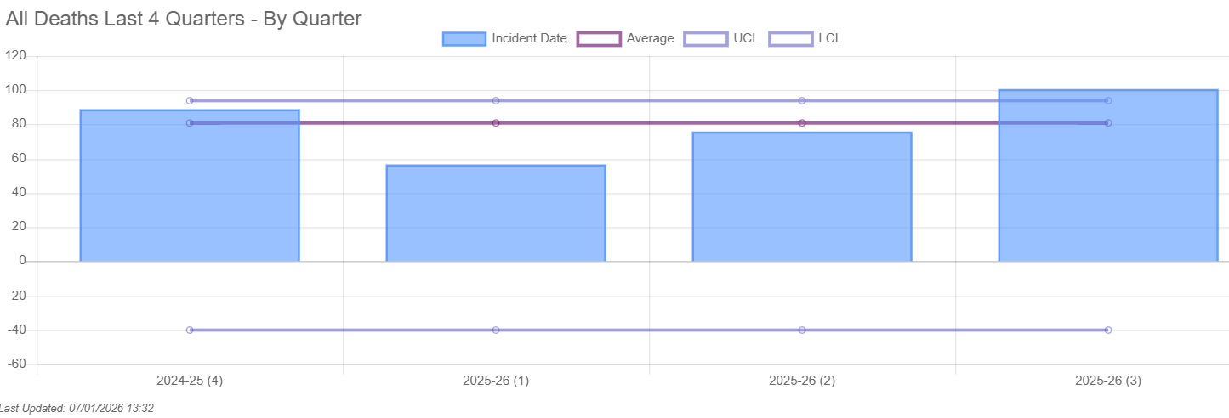
Graph 3 – Number of Deaths reported by month
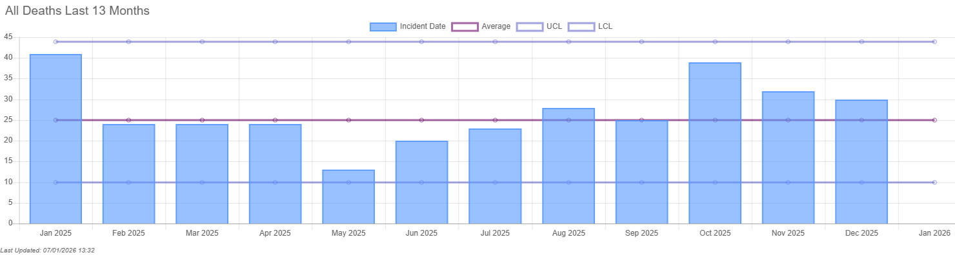
Death under the care of the National Health Service (NHS) is an inevitable outcome for some patients and patients may experience good and excellent care in the months or years leading up to their death. The reporting of deaths and governance arrangements support BDCFT to identify learning where care could be improved and where the good practice can be shared. The reports indicate that the learning required arises from multiple contributory factors, which are system-wide issues and feed into quality improvement activity.
Sallie Turner
Mortality & Duty of Candour Improvement Facilitator

Tricia George,
Head of Patient Safety/Patient Safety Specialist
15 January 2025

