Senior Leadership Team (SLT) - Quality, Safety and Governance
16 October 2025

Paper title: | Learning from Deaths - Quarter 2 2025/26 |  |  | Agenda  Item  XX
Presented by: | Dr Sal Uka, Medical Director  Dr Sarfaraz Shora, Deputy Medical Director |  |  | Agenda  Item  XX
Prepared by: | Sallie Turner, Mortality & Duty of Candour Improvement Facilitator  Rachel Howitt, Head of Patient Safety/Patient Safety Specialist |  |  | Agenda  Item  XX
Committees where content has been discussed previously |  | n/a
Purpose of the paper  Please check ONE box only: |  | ☐ For approval  ☐ For discussion | ☒ For information

Relationship to the Strategic priorities and Board Assurance Framework (BAF)
The work contained with this report contributes to the delivery of the following themes within the BAF
Being the Best Place to Work | Looking after our people
Being the Best Place to Work | Belonging to our organisation
Being the Best Place to Work | New ways of working and delivering care
Being the Best Place to Work | Growing for the future
Delivering Best Quality Services | Improving Access and Flow
Delivering Best Quality Services | Learning for Improvement | √
Delivering Best Quality Services | Improving the experience of people who use our services | √
Making Best Use of Resources | Financial sustainability
Making Best Use of Resources | Our environment and workplace
Making Best Use of Resources | Giving back to our communities
Being the Best Partner | Partnership
Good governance | Governance, accountability & oversight | √

Purpose of the report
The purpose of this report it to provide Board with an overview of the learning the Trust has taken from the deaths of patients within its care during Q2, 2025/26.

Executive Summary
Learning from deaths is supported by two key policies in Bradford District Care Foundation Trust (BDCFT), the Patient Safety Incident Response Policy and associated Plan (PSIRP) and the Learning from Deaths (LfD) Policy. These policies guide and inform the organisation about reporting, investigating and learning from deaths. Between 01 July 2025 and 30 September 2025 there have been 68 deaths reported. This is a 4% increase compared with the same period the previous year.

4 Patient Safety Incident Investigation reports have been completed. 0 Structured Judgement Reviews (SJRs) commissioned by the Patient Safety Executive Panel (PSEP) have been completed.

Learning from excellence and learning for improvement was identified in all cases and continues to be shared with teams and across the organisation.
Do the recommendations in this paper have any impact upon the requirements of the protected groups identified by the Equality Act? | ☐ Yes (please set out in your paper what action has been taken to address this)  ☒ No

Recommendation(s)
The SLT - Quality, Safety and Governance group is asked to:

- Note the content of the report and take assurance that our processes for reviewing and learning from deaths is robust and appropriate

Links to the Strategic Organisational Risk register (SORR) | The work contained with this report links to the following corporate risks as identified in the SORR:  - n/a
Care Quality Commission domains  Please check ALL that apply | ☒ Safe  ☐ Effective  ☒ Responsive | ☒ Caring  ☒ Well-Led
Compliance & regulatory implications | The following compliance and regulatory implications have been identified as a result of the work outlined in this report:  - n/a

SLT - Quality, Safety and Governance
16 October 2025

Learning from Deaths 2025/2026 Q2

Introduction and background
Learning from deaths is supported by two key policies in BDCFT; the Patient Safety Incident Response Policy and associated Plan (PSIRP) and the Learning from Deaths (LfD) Policy. These policies guide and inform the organisation about reporting, investigating and learning from deaths.
Current Status
Between 01 July 2025 and 30 September 2025, a total of 68 of Bradford District Care NHS Foundation Trust’s patients died. There were 65 in Q2 last year.
During Q2 there were 4 reported deaths of a Service User with a registered Learning Disability and/or a clinical diagnosis of Autism. These have undergone Learning for Lives and Deaths (LeDeR) service improvement reviews.
Table 1: Number of reported patient deaths per quarter (rolling 12 months)
 | Quarter 3  24/25 | Quarter 4  24/25 | Quarter 1  25/26 | Quarter 2  25/26
Number of patients who have died during previous 12 months | Oct - 22  Nov - 31  Dec - 41 | Jan – 33  Feb – 18  Mar - 18 | April – 20  May – 10  June - 19 | Jul – 22  Aug – 25  Sept – 21
Total per quarter | 94 | 69 | 49 | 68
Total number of patients who have died in the last 4 quarters | 280

To note: the total numbers presented per quarter in this report may be slightly different if compared directly to previous reports. This is due in part to the data cleansing process, and also due to variance at the time of data extraction for the reporting period. This slight variance is created by some deaths not being included in a quarters data at the time of developing the report, because the Trust was notified and/or the death was reported in a later quarter. Data is correct at the time of report development and will be adjusted to reflect an accurate account at year end.
All deaths, whether expected due to a clinical condition or unexpected, are reviewed bi-weekly in the Patient Safety Executive Panel (PSEP) which aligns with good governance processes under the Patient Safety Incident Response Framework (PSIRF) requirements which commenced in April 2024 and reviewed and approved in June 2025.
This group commissions reviews of case notes from a sample of deaths using the Structured Judgment Review (SJR) tool. This is a national tool developed by the Royal College of Psychiatrists to allow clinicians to take an expert view of the care offered. The Group may also commission initial reviews which do not consider the full range of factors within the SJR review to understand if an SJR is appropriate, or where an SJR is not required but where there may be learning, other review methods may be used; for example a Local Learning Review (LLR), After Action Review (AAR) or Thematic Analysis (TA) to identifying learning in order to minimise the risk of future harm.
The Patient Safety Executive Panel considers the outcomes of the reviews and asks the relevant Quality and Operational (QuOPs) meeting to develop an action plan in regard to any areas where it has been suggested that care should be improved. Issues that are of general relevance will be added to the trust Patient Safety and Learning page to enable broader sharing across the organisation. For all deaths of patients who have a Learning Disability, the initial review is shared in the Patient Safety Executive Panel and they are referred to the national Learning for Lives and Deaths (LeDeR) programme.
The Mortality screening tool, embedded on Safeguard (the Trust’s Local Risk Management System where all deaths are reported), continues to enable reporters to provide more complete information regarding deaths at an earlier point. This is helping facilitate the decisions at PSEP regarding level of review/investigation required.
The number of deaths in each quarter for which a Review, Thematic Analysis or Patient Safety Incident Investigation (PSII) was carried out are shown in the following table:
 | Quarter 3  24/25 | Quarter 4  24/25 | Quarter 1  25/26 | Quarter 2  25/26
Number of deaths for which a Structured Judgement Review was completed | 1 | 1 | 5 | 0
Number of deaths for which a Local Learning Review was completed | 2 | 0 | 1 | 2
Number of deaths for which an After Action Review was completed | 0 | 0 | 0 | 0
Number of deaths which were included in a completed Thematic Analysis | 10 | 0 | 4 | 0
Number of deaths for which a PSII was completed | 6 | 1 | 6 | 4
Number of deaths of persons with learning disabilities or Autism, referred for local LeDeR review. | 9 | 9 | 3 | 4

Please note:
4 PSII investigations were for deaths that occurred in the previous reporting periods and the investigations were completed in this reporting period (Q2 25/26).
2 LLRs were for deaths that occurred in the previous reporting periods and the investigations were completed in this reporting period (Q2 25/26).
All types of incident response (PSII, SJR, TA, LLR or AAR) have the same remit of identifying system learning for improvement.

Learning and Improvement
BDCFT takes a proactive approach to learning from deaths and the following summary highlights where good practice and areas identified for improvement have been highlighted during Q2, 2025/26. This learning is used to shape future quality and safety improvements.
Learning from good practice and excellence:
A number of reviews were conducted that concluded good and excellent care had been provided by various inpatient and community teams.
Some examples of this were:
- Staff responded rapidly when a deterioration in physical heath was noted.
- Regular review of observations, and timely increase where appropriate.
- Positive risk management promoting independence by limiting the risk of service dependence.
- Prompt response to PRN (Latin phrase for pro re nata) medication when required.
- Enhanced engagement was utilised with appropriately skilled staff, with the aim of safeguarding the patient, other service users and staff to prevent allegations/accusations and to encourage positive behavioural adjustments.
- Care plans and risk assessments overall were detailed and included all elements of risk, including previous detailed incidents
- Speedy response to Infection and Prevention control measures
- Patient encouraged to engage and joined in with Occupational Therapy events
- The initial assessment was detailed and recorded the patient’s described needs
- Referral from receipt to screening and assessment was timely and consistent
- A proactive approach was delivered in the planning of interventions including rearranging appointments at request of the Patient
- Staff consulted with family and the police to ensure it was recognised that the patient was a high-risk missing person.
- Inpatient and community clinical and support staff showed a compassionate and individualised approach to supporting Patient A and managing his medical, emotional and social needs.
- There is strong evidence of effective teamwork, inter-agency communication and professional curiosity.
- BDCFT have improved joined up working around co-occurring mental ill health and substance misuse, and the new service was accessed for Patient X.
- Multi-agency working was effective and in line with policy, considering Patient’s complex mental health and social situation

Learning for improvement:
Some learning was identified from a number of reviews where care had not gone so well, and improvements could be made. An action plan is developed for all events where learning is identified and is monitored through the operational quality improvement processes in the Trust, with oversight via QuOps structures and in the Patient Safety and Learning Group (PSLG).
Some examples of the learning identified were:
- Care plan did not include a detailed treatment/action plan around physical health needs, condition, monitoring and reviews
- Risk Assessments were out-of-date
- Poor documentation and in-consistent information around the level of observations.
- Confusion with the guidance in the Incident Reporting and Management Policy resulting in an incident form not being completed when the patient was admitted to the acute hospital.
- Baseline monitoring for lithium was not fully adhered to.
- Patient prescribed multiple benzodiazepines concurrently; contrary to recommended practice.
- Monitoring forms for rapid tranquilisation were inconsistently saved on SystmOne, complicating their retrieval.
- Patient received unprescribed oxygen several times
- The ward did not possess the facilities for emergency airway management or continuous oxygen delivery.
- Indications of distress were evident in contact with Yorkshire Ambulance Service (YAS) but this assessment did not result in any escalation to BDCFT services.
- No local guidance exists for BDCFT staff around how and when demographic information should be updated on BDCFT systems.
- Husband was not involved in his wife’s assessment and care, despite obtaining consent for information sharing with him.
- Interfaces and pathways are not clearly understood or defined between acute community teams (Intensive Home Treatment Team (IHTT) and Older People’s (OP) Acute Liaison Psychiatry Service (ALPS)) and the Older Adults (OA) Community Mental Health Team (CMHT) for older adults.
- Relevant SystmOne templates are to be amended further to include specific and more detailed questions around carers.
- The quality of care and safety planning was not in line with expected practice including documentation and oversight by the Multi-Disciplinary Team (MDT).
- No communication between IHTT staff and Children and Families Trust as required by trust policy or seeking of advice from the trust’s Safeguarding Team.
- There is no BDCFT specific self-harm policy, based on the National Institute of Health and Care Excellence (NICE) guidelines, to enable staff to engage with service users in a clear therapeutic way and deliver evidence-based interventions.
- BDCFT search policy requires review so use on the inpatient wards is consistent and ensures that staff training on search is current and up to date.
- Previous action plan not implemented in a timely manner.

Next steps
A number of developments are ongoing to enable the workstreams in relation to mortality to improve and mature.
Under the LfD Framework with the National Quality Board (NQB) we are required to further review a sample of deaths, that do not fit within the main identified categories, so we can take a broader overview of where learning and improvement is needed. The sample for the next review is currently in development and will be allocated via the lead reviewer in Q3.

Local Learning Review training has continued to be delivered to staff to expand on the use and development of systems-based PSIRF approaches to incident response, and to support the organisation in ensuring that meaningful learning is identified from reviews. To date, 40 staff members have undertaken this training with a further 11 booked onto remaining sessions throughout the rest of the year.

BDCFT’s participation in the ‘Northern Alliance’ of mental health trusts is continuing well. Progress has begun with some focussed discussions around developing an online SJR training package and reviewing LfD reporting metrics for better aligning these across the Bradford and Craven Place.
The PSEP group receives a Coroners Learning from Deaths Summary Report on a monthly basis. This provides a summary of national Prevention of Future Death Reports and is also received by the Patient Safety and Learning Group (Insights) to inform triangulation and any safety action required.
Conclusion
For Q2, 2024/25 there has been a 4% increase on the number of deaths reported compared to the same period last year. There has been a 38% increase in the number of deaths reported in Q2 of 2025/26 compared to Q1 of 2025/2026. This increase is a significant increase in comparison to the previous 2 years which saw a 19% decrease for the same periods last year and a 26% decrease the year before that, however Q1 had a lower than normal total of deaths compared to the previous 2 years, so the increase is less significant when reviewed on a yearly basis.
The main variance within the data represents deaths from clinical conditions, deaths of unknown cause and suspected suicide remain relatively consistent:
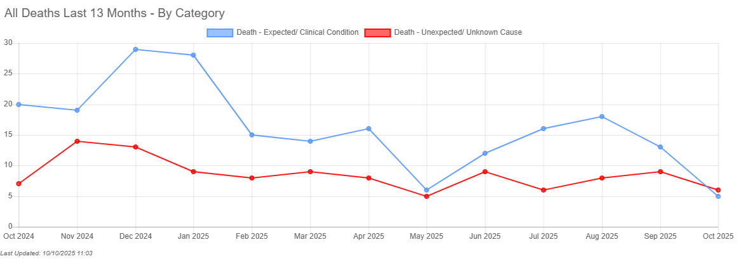
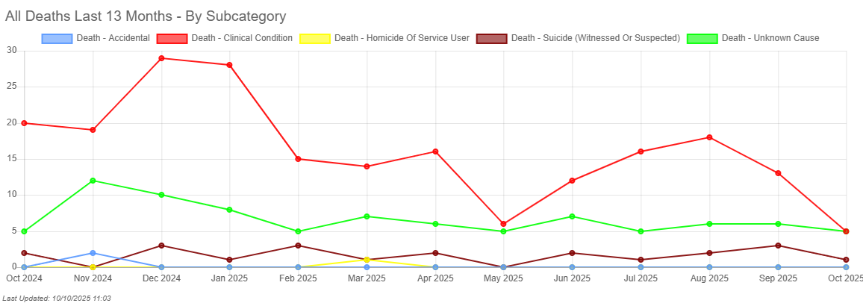
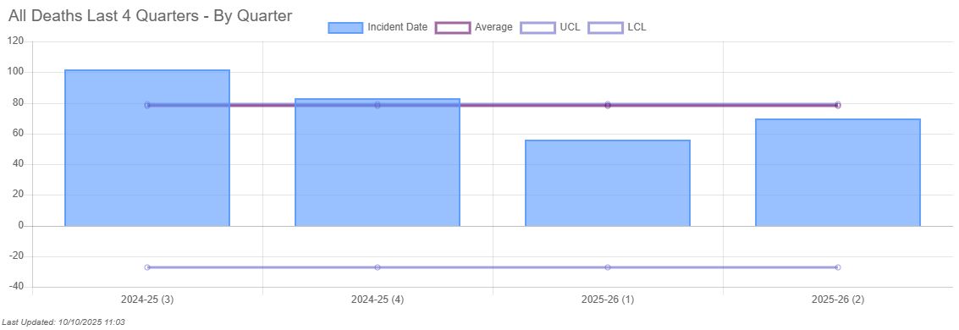
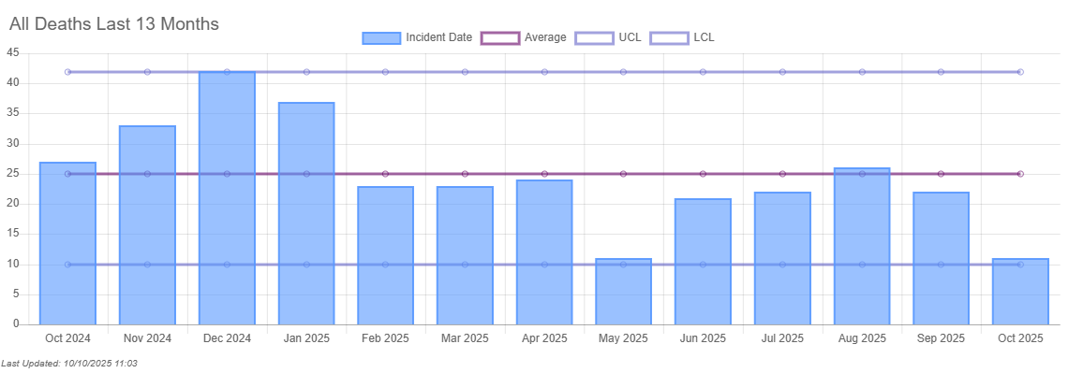

Death under the care of the National Health Service (NHS) is an inevitable outcome for some patients and patients may experience good and excellent care in the months or years leading up to their death. The reporting of deaths and governance arrangements support BDCFT to identify learning where care could be improved and where the good practice can be shared. The reports indicate that the learning required arises from multiple contributory factors, which are system-wide issues and feed into quality improvement activity.

Sallie Turner
Mortality & Duty of Candour Improvement Facilitator

Rachel Howitt
Head of Patient Safety / Patient Safety Specialist
13 October 2025

