Senior Leadership Team (SLT) - Quality, Safety and Governance
17 July 2025

Paper title: | Learning from deaths and Patient Safety Incident Investigations |  |  | Agenda  Item  XX
Presented by: | Dr David Sims, Medical Director |  |  | Agenda  Item  XX
Prepared by: | Sallie Turner, Mortality & Duty of Candour Improvement Facilitator  Rachel Howitt, Head of Patient Safety/Patient Safety Specialist |  |  | Agenda  Item  XX
Committees where content has been discussed previously |  | n/a
Purpose of the paper  Please check ONE box only: |  | ☐ For approval  ☐ For discussion | ☒ For information

Relationship to the Strategic priorities and Board Assurance Framework (BAF)
The work contained with this report contributes to the delivery of the following themes within the BAF
Being the Best Place to Work | Looking after our people
Being the Best Place to Work | Belonging to our organisation
Being the Best Place to Work | New ways of working and delivering care
Being the Best Place to Work | Growing for the future
Delivering Best Quality Services | Improving Access and Flow
Delivering Best Quality Services | Learning for Improvement | √
Delivering Best Quality Services | Improving the experience of people who use our services | √
Making Best Use of Resources | Financial sustainability
Making Best Use of Resources | Our environment and workplace
Making Best Use of Resources | Giving back to our communities
Being the Best Partner | Partnership
Good governance | Governance, accountability & oversight | √

Purpose of the report
The purpose of this report it to provide Board with an overview of the learning the Trust has taken from the deaths of patients within its care during Q1, 2025/26.

Executive Summary
Learning from deaths is supported by two key policies in Bradford District Care Foundation Trust (BDCFT), the Patient Safety Incident Response Policy (PSIRP) and the Learning from Deaths (LfD) Policy. These policies guide and inform the organisation about reporting, investigating and learning from deaths. Between 01 April 2025 and 30 June 2025 there have been 49 deaths reported. This is a 41% reduction compared with the same period the previous year.

6 Patient Safety Incident Investigation reports have been completed. 5 Stuctured Judgement Reviews (SJRs) commissioned by the Patient Safety Executive Panel (PSEP) have also been completed.

Learning from excellence and learning for improvement was identified in all cases and continues to be shared with teams and across the organisation.
Do the recommendations in this paper have any impact upon the requirements of the protected groups identified by the Equality Act? | ☐ Yes (please set out in your paper what action has been taken to address this)  ☒ No

Recommendation(s)
The SLT - Quality, Safety and Governance group is asked to:

- Note the content of the report and take assurance that our processes for reviewing and learning from deaths is robust and appropriate

Links to the Strategic Organisational Risk register (SORR) | The work contained with this report links to the following corporate risks as identified in the SORR:  - n/a
Care Quality Commission domains  Please check ALL that apply | ☒ Safe  ☐ Effective  ☒ Responsive | ☒ Caring  ☒ Well-Led
Compliance & regulatory implications | The following compliance and regulatory implications have been identified as a result of the work outlined in this report:  - n/a

SLT - Quality, Safety and Governance
17 July 2025

Learning from Deaths 2025/2026 Q1

Introduction and background
Learning from deaths is supported by two key policies in BDCFT; the Patient Safety Incident Response Policy (PSIRP) and the Learning from Deaths (LfD) Policy. These policies guide and inform the organisation about reporting, investigating and learning from deaths.
Current Status
Between 01 April 2025 and 30 June 2025, a total of 49 of Bradford District Care NHS Foundation Trust’s patients died. There were 84 in Q1 last year.
During Q1 there were 3 reported deaths of a Service User with a registered Learning Disability and/or a clinical diagnosis of Autism. These have undergone Learning for Lives and Deaths (LeDeR) service improvement reviews.
Table 1: Number of reported patient deaths per quarter (rolling 12 months)
 | Quarter 2  24/25 | Quarter 3  24/25 | Quarter 4  24/25 | Quarter 1  25/26
Number of patients who have died during previous 12 months | Jul – 20  Aug – 22  Sept – 23 | Oct - 22  Nov - 31  Dec - 41 | Jan – 33  Feb – 18  Mar - 18 | April – 20  May – 10  June - 19
Total per quarter | 65 | 94 | 69 | 49
Total number of patients who have died in the last 4 quarters | 277

To note: the total numbers presented per quarter in this report may be slightly different if compared directly to previous reports. This is due in part to the data cleansing process, and also due to variance at the time of data extraction for the reporting period. This slight variance is created by some deaths not being included in a quarters data at the time of developing the report, because the Trust was notified and/or the death was reported in a later quarter. The data was correct at the time of report development and has now been adjusted to reflect an accurate account at year end.
All deaths, whether expected due to a clinical condition or unexpected, are reviewed bi-weekly in the Patient Safety Executive Panel (PSEP) which aligns with good governance processes under the Patient Safety Incident Response Framework (PSIRF) requirements which commenced in April 2024.
This group commissions reviews of case notes from a sample of deaths using the Structured Judgment Review (SJR) tool. This is a national tool developed by the Royal College of Psychiatrists to allow clinicians to take an expert view of the care offered. The Group may also commission initial reviews which do not consider the full range of factors within the SJR review to understand if an SJR is appropriate, or where an SJR is not required but where there may be learning, other review methods may be used; for example a Local Learning Review (LLR), After Action Review (AAR) or Thematic Analysis (TA) to identifying learning in order to minimise the risk of future harm.
The Patient Safety Executive Panel considers the outcomes of the reviews and asks the relevant Quality and Operational (QuOPs) meeting to develop an action plan in regard to any areas where it has been suggested that care should be improved. Issues that are of general relevance will be added to the trust Patient Safety and Learning page to enable broader sharing across the organisation. For all deaths of patients who have a Learning Disability, the initial review is shared in the Patient Safety Executive Panel and they are referred to the national Learning for Lives and Deaths (LeDeR) programme.
The Mortality screening tool, embedded on Safeguard (the Trust’s Local Risk Management System where all deaths are reported), continues to enable reporters to provide more complete information regarding deaths at an earlier point. This is helping facilitate the decisions at PSEP regarding level of review/investigation required.
The number of deaths in each quarter for which a Review, Thematic Analysis or Patient Safety Incident Investigation (PSII) was carried out are shown in the following table:
 | Quarter 2  24/25 | Quarter 3  24/25 | Quarter 4  24/25 | Quarter 1  25/26
Number of deaths for which a Structured Judgement Review was completed | 5 | 1 | 1 | 5
Number of deaths for which a Local Learning Review was completed | 3 | 2 | 0 | 1
Number of deaths for which an After Action Review was completed | 0 | 0 | 0 | 0
Number of deaths which were included in a completed Thematic Analysis | *Not previously broken down by type, figures included in the above* | 10 | 0 | 4
Number of deaths for which a PSII was completed | 5 | 6 | 1 | 6
Number of deaths of persons with learning disabilities or Autism, referred for local LeDeR review. | 2 | 9 | 9 | 3

Please note:
5 SJRs monitored via the patient safety process were deaths that occurred in previous reporting periods and the reviews were completed in Q1 2025/26.
6 PSII investigations were for deaths that occurred in the previous reporting periods and the investigations were completed in this reporting period (Q1 25/26).
All types of incident response (PSII, SJR, TA, LLR or AAR) have the same remit of identifying system learning for improvement.

Learning and Improvement
BDCFT takes a proactive approach to learning from deaths and the following summary highlights where good practice and areas identified for improvement have been highlighted during Q1, 2025/26. This learning is used to shape future quality and safety improvements.
Learning from good practice and excellence:
A number of reviews were conducted that concluded good and excellent care had been provided by various inpatient and community teams.
Some examples of this were:
- patient’s individual choices were central to care and treatment decisions made
- consistency and willingness of staff to support patient with community resources
- perceived risk was effectively managed in relation to non-engagement
- consistent exploration and action of safeguarding concerns
- therapeutic engagement process commenced early (prior to discharge)
- service user and family engagement in developing robust plans for discharge
- good inter-agency communication to ensure safe and structured discharge
- good engagement with immigration service to support service user and their family
- person centred care, thoughtful and in line with the assessment and treatment pathway
- patient wishes were respected when declining aspects of care
- good medication management with trials and consideration of escalation of treatment
- proactive unannounced visits, reflecting commitment when engagement limited
- prompt referral demonstrated adherence to care escalation protocols
- patient medication preference considered showing good, shared care planning
- effective collaboration with other agencies regarding patient’s physical health
- timely review by First Response Service (FRS) with clearly documented associated risks and safety planning

Learning for improvement:
Some learning was identified from a number of reviews where care had not gone so well, and improvements could be made. An action plan is developed for all events where learning is identified and is monitored through the operational quality improvement processes in the Trust, with oversight via QuOps structures and in the Patient Safety and Learning Group (PSLG).
Some examples of the learning identified were:
- General Practitioner (GP) referrals* are not always received via electronic record or telephone correctly
- GP referrals* do not always provide sufficient information to facilitate timely triage
- absence of a consistent approach to ensure the quality of professional-to-professional handovers when a service user was transferred between providers*
- miscommunication regarding resuscitation status between agencies*

*where learning relates to non BDCFT services, this is shared with the relevant provider

- referral system and processes can be improved to ensure improved transparency of receipt, proposed or actual action(s) taken and decision making by teams involved
- average wait time between Community Mental Health Team (CMHT) assessment and onward referral (for CMHT or psychology consideration) remains 61 days (however improvement work acknowledged)
- review of medication not actioned in a timely manner or rationale not documented for if service considered action was not appropriate
- no process for providing condolences when service user dies whilst between services
- risk assessment document did not provide sufficient up to date information about known risks of suicidal ideation and acting with intent; self-injury or harm; and self-neglect
- safeguarding issues were not recorded within the risk assessment document
- limited evidence within patient record of consideration of child safeguarding, emerging risk, crisis behaviour to inform risk assessment, formulation and safety planning
- out of area Trust request for a referral to Intensive Home Treatment Team (IHTT) was not completed due to a misunderstanding about how referrals are processed by an individual crisis team
- review provision of clinical risk training to ensure it reflects current guidelines and best practice (National Institute for Health and Care Excellence (NICE) 2022 and NHS England 2025)
- monitor updated triage templates, which may alert FRS to an increasing pattern of contacts, particularly within a 7-day period, as there is no current digital solution
- systems were inconsistent to support multi-agency review opportunities for vulnerable service users who struggle to engage and move between services and areas
- consideration of domestic abuse to be included in current policies/templates, and potential for domestic violence training to be mandatory
- increased training focussing on the impact of medications on mental health
- handover document between services should include carer/nearest relative details for potential emergency contact
- increased awareness about the impact of bereavement on suicide risk and exploring significant associated dates should be a routine part of assessment
- falls risk assessment incomplete or inaccurate and a lack of mitigating interventions to reduce the risk of falls when the service user’s presentation changed
- absence of a central point of expertise or leadership in relation to the minimisation and mitigation of falls risk; review need for Trust falls lead
- service user’s fall was reported, but subsequent death was not reported via the incident reporting system, so relevant teams unaware until contact by His Majesty’s Coroner (HMC)
- family were not contacted prior to attending unit to inform that visit was not possible
- service user not accepted on to the mental health service caseload despite an earlier referral, resulted in signposting to primary care wellbeing services
- decisions regarding care and treatment were taken by mental health professionals not working in the clinical speciality
- clinical contacts not consistently undertaken in service user’s main spoken language
- review current processes for triaging referrals to ensure individualised responses
- review the current pathway including the use of specialist practitioners, and reducing inappropriate use of acute provider beds for the mitigation of mental health risks
- consider more proactive approach for patients who frequently cancel appointments and visits to enable support for the carer and to assess engagement concerns
- earlier allocation of a care coordinator to ensure optimal period to make progress
- possible missed opportunity to mitigate overdose risk by limiting dispensing quantity
- the method of planned daily contact was not clearly documented
- lack of clarity in notes regarding diagnosis, with variations to the disorder disclosed
- inconsistency in documentation of risk assessment and mental state presentation
- lack of documented detail/conclusion relating to how capacity was assessed
- update No Access Visit procedure to specify all areas to be included when property search is undertaken commensurate with the identified level of risk

Next steps
A number of developments are ongoing to enable the workstreams in relation to mortality to improve and mature.
An annual review and refresh of the Trusts Patient Safety Incident Response Plan (PSIRP) has been undertaken to ensure ongoing responses to patient safety incidents (including deaths) are appropriate, in line with legislation, best practice and guidance and actively promotes and supports a just learning and generative safety culture across the organisation.

Under the LfD Framework with the National Quality Board (NQB) we are required to further review a sample of deaths, that do not fit within the main identified categories, so we can take a broader overview of where learning and improvement is needed. The learning from this sample is currently being triangulated with other reviews and used to inform improvement. Initial findings show that safe, high-quality care was provided across all 15 of these SJRs.

Local Learning Review training has continued to be delivered to staff to expand on the use and development of systems-based PSIRF approaches to incident response, and to support the organisation in ensuring that meaningful learning is identified from reviews. To date, 31 staff members have undertaken this training with further session planned throughout the rest of the year.

BDCFT’s participation in the ‘Northern Alliance’ of mental health trusts is continuing well. Progress has begun with some focussed discussions around developing an online SJR training package and reviewing LfD reporting metrics for better aligning these across the Bradford and Craven Place.
The PSEP group receives a Coroners Learning from Deaths Summary Report on a monthly basis. This provides a summary of national Prevention of Future Death Reports and is also received by the Patient Safety and Learning Group (Insights) to inform triangulation and any safety action required.
Conclusion
For Q1, 2024/25 there has been a 41% decrease on the number of deaths reported compared to the same period last year. There has been a 29% decrease in the number of deaths reported in Q1 of 2025/26 compared to Q4 of 2024/25. This decrease is a significant change in comparison to the previous 2 years which saw a 5% increase for the same periods last year and a 5% decrease the year before that.

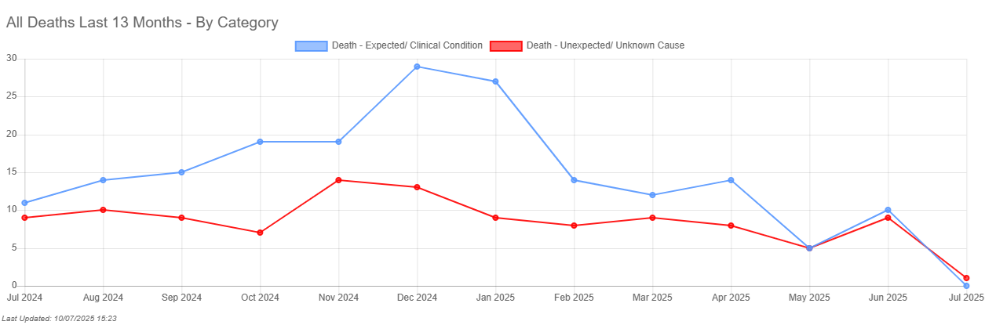

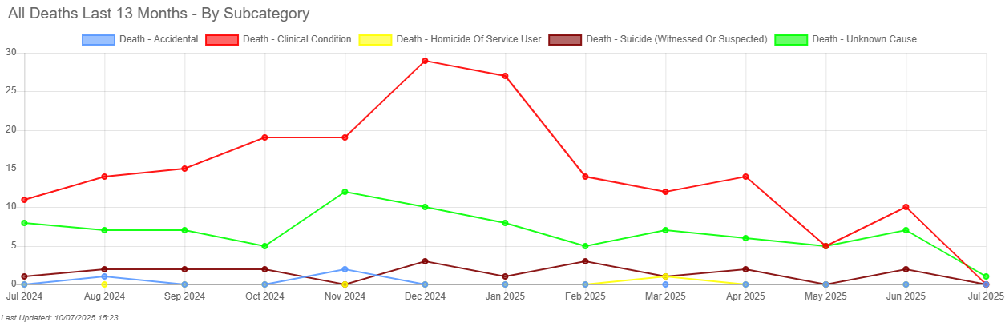

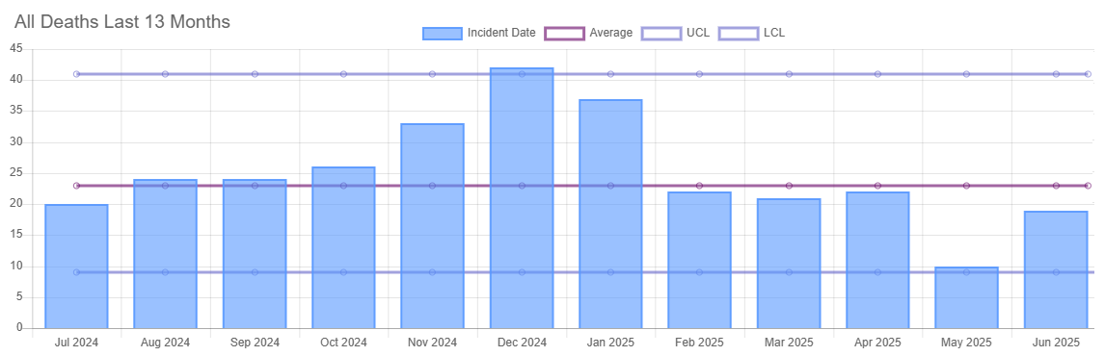

Death under the care of the National Health Service (NHS) is an inevitable outcome for some patients and patients may experience good and excellent care in the months or years leading up to their death. The reporting of deaths and governance arrangements support BDCFT to identify learning where care could be improved and where the good practice can be shared. The reports indicate that the learning required arises from multiple contributory factors, which are system-wide issues and feed into quality improvement activity.

Sallie Turner
Mortality & Duty of Candour Improvement Facilitator

Rachel Howitt
Head of Patient Safety / Patient Safety Specialist
14 July 2025

