Equality Delivery System 2022
Domain 2 Draft Scores 2026

Ratings: 0 = Underdeveloped, 1 = Developing, 2 = Achieving, 3 = Excelling EDS Ratings and Score Card Guidance

Domain | Outcome | Evidence | Rating | Owner (Dept/Lead)
Domain 2:  Workforce health and well-being | 2A: When at work, staff are provided with support to manage obesity, diabetes, asthma, COPD and mental health conditions | The organisation has a comprehensive wellbeing offer for staff. This includes a wide range of opportunities including:  - Physical health, mental health, and financial wellbeing.  Staff have access to a physical exercise and relaxation timetable, therapy, occupational therapy, physical health checks, referrals to expert VCS and specialist organisations.  There is information specifically designed for diverse colleagues, support with childcare, domestic abuse, menopause and neurodiversity.  This includes direct information about weight management, smoking cessation, mental health and diabetes. A wellbeing room is available to staff for to measure weight, blood pressure and access health information and support.  Since the first EDS22 assessment the Wellbeing Team have developed a set of strategic objectives which focus on 4 areas:  - Targeting the offer into services and teams guided by data on wellbeing from the staff survey, sickness rates, staff who are digitally excluded.  - Measuring take up and effectiveness by equality group where possible.  - Working strategically to make wellbeing everyone’s responsibility.  - Effective use of the wellbeing budget.  The focus group sessions are underway with the groups of staff identified to be harder to reach due to digital or rural exclusion. Including Estates & Facilities, Catering, Ward staff and those based at sites further afield from the Trust headquarters (such as Skipton).  The Wellbeing Team now presents on the Manager Essentials course to ensure managers understand their responsibility around team wellbeing. Specific separate Wellbeing and Childcare sessions for managers are scheduled throughout 2026.  A Living Well Workplaces programme is commencing in January 2026 to focus on the wellbeing of staff at Lynfield Mount Hospital (LMH). The piece of work will include a survey to staff based at this site to find out what support they need, whether it be physical exercise, eating better, smoking cessation or mental health assistance and a support package will be tailor made by Living Well to support these colleagues. The aim is to extend this offer to other sites following the succession at LMH.  Focus groups have taken place with teams that scored low in the health and wellbeing or MSK questions on the staff survey and actions have begun to take place from these. Such as:  - Equipment being demonstrated to teams who feel they are lacking essential items to support them in work.  - In discussions with our internal Podiatry service to explore the potential of specific literature/ guidance around appropriate footwear and whether any in person sessions can be offered to staff.  - Guidance on appropriate exercises for staff predominantly sedentary workers.  - Exploration into options for suitable and affordable shoes.  - Development of the Wellbeing Champions is underway with an aim to have a champion based within each team across the district.  More information on the above is included in appendix 1.  73% of staff who have accessed physiotherapy through the Trusts wellbeing offer are female which is 7% less than the percentage of Trust staff who are female. 33% are ethnically diverse staff which is just 1% higher than the percentage of ethnically diverse staff in the Trust. 20% of people who have accessed physiotherapy have a disability which is higher then the percentage of Trust staff with a disability.  For Occupational Health 77% of staff who have accessed it are female, 37% are ethnically diverse and 23% have a disability.  A new Staff Wellbeing Room is being developed within the refurbishment of New Mill. Based on the feedback from the LMH site Staff Wellbeing Room, this will be a “relaxation room” which will allow staff somewhere safe and comfortable to decompress when feeling overwhelmed or overstimulated in the workplace.  A health and wellbeing summary leaflet is being developed to give an overview of all the offers available including various entry points to the service.  Specific support for obesity, diabetes, asthma, COPD and mental health conditions is available to staff through the Long-Term Health Conditions Rehabilitation Service.  In addition to these wide-ranging staff support offers the Trust has mapped the workforce against the Index of Multiple Deprivations. A Health Equity Approach is being developed to ensure the Trust is strategically driving change across the whole organisation and its services.  The Trust has Mental Health First Aiders and a Wellness Action Plan that sits alongside the supervision and reasonable adjustment processes.  Demographics of staff accessing PhysioMed, Occupational Health and Affinity Connect are recorded now. This recording will be expanded throughout 2026.  Trust wide survey on the health and wellbeing offer is due to go out at the beginning of 2026.  648 contacts have been reached at wellbeing roadshows and190 contacts reached at a childcare roadshows.  Additional check points have been added to the Childcare Support Service process for maternity, paternity and adoption leave. Managers and staff or due to go on leave are now contacted when the Trust is notified of their leave application and two months prior to the staff members return to work. A review of maternity and return to work processes has been undertaken and the findings will be developed into an action plan.  The Beacon Network has conducted a menti review of disabled and working carers staff wellbeing. The network measured the wellbeing as being 6.5 out of 10. The network members were asked who had accessed what from the wellbeing offer:  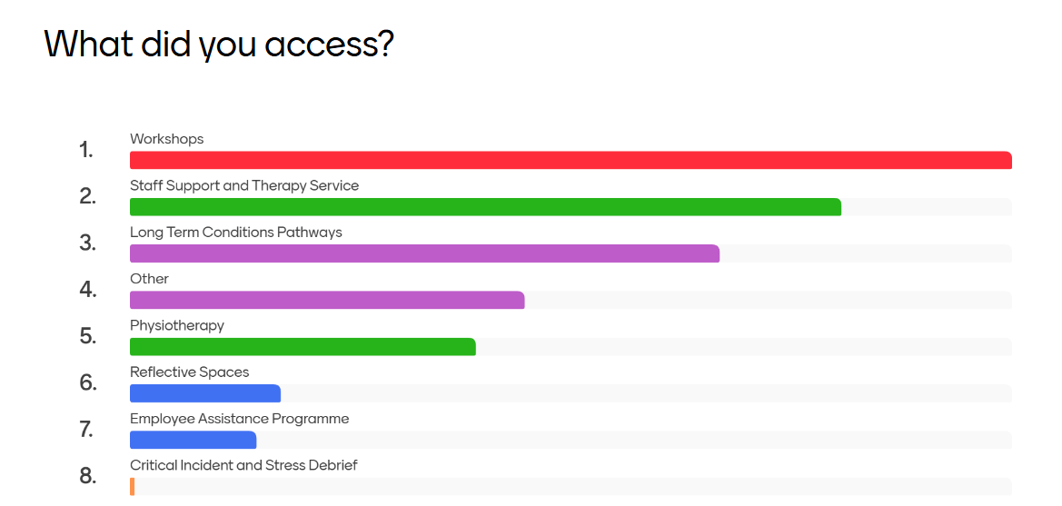  Members were asked how the support had affected their health and wellbeing:  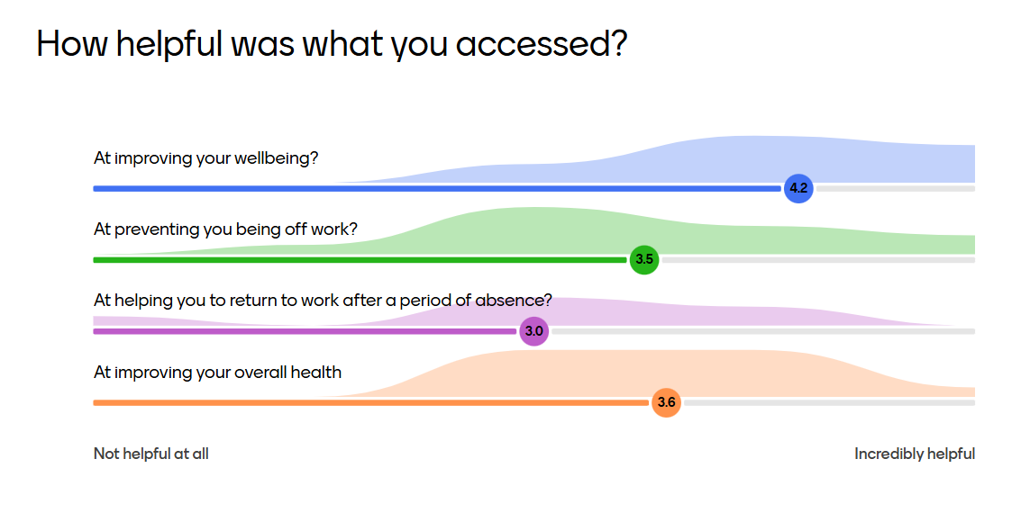 | 3 | Workforce Development and Organisational Development  - Wellbeing Team.  - Equality, Diversity and Inclusion Team.  - Staff Support and Therapy Service.  - Vocational Physical Health and Wellbeing Service.  - Occupational Health Service.  - BDCFT managers.
Domain 2:  Workforce health and well-being | 2B: When at work, staff are free from abuse, harassment, bullying and physical violence from any source | The Trust has a Dignity and Respect in the workplace policy which has been revised to include definitions and examples of sexual harassment. The Managing Racial and Other Types of Abuse from Patients and/or the Public has an implementation programme in place. This includes a framework for tackling abuse. Training is delivered regularly to staff on these policies and how to implement them. A Sexual Safety Policy has been developed.  One to One structures and Team Huddles start with wellbeing check ins providing colleagues with an opportunity to raise any concerns.  The Trust analyses staff survey data systematically and includes interventions where inequalities are identified in Workforce Race Equality Standard and Workforce Disability Standard plans - Equality and diversity reports - Bradford District Care NHS Foundation Trust.  The Trusts Disciplinary Policy has been revised and a live Employee Relations case tracker has been implemented. A standard monthly report has been created to monitor grievances and disciplinaries, themes and trends.  In addition, the Trust has a Framework for addressing Racial and Other Types of Abuse and has signed up for the Royal College of Psychiatrists Act Against Racism framework.  The Trust has thriving staff networks. The Aspiring Cultures Staff Network have recently conducted a review of staff’s satisfaction in the way the Trust manages incidents of racial and other types of abuse to staff. The Beacon Network has had themes of work this year focusing on avoidable harm in employee relations processes and wellbeing as mentioned in 2a.  The Trust has an incident reporting process to ensure any incident that is verbally and/or physically abusive or abusive under the Equality Act is reported within that category to support the identification of hot spots and themes. Regular reports are received for analysis. In hotspot areas, partnerships have been developed with the police to improve response rates and interventions with perpetrators in our services. Data is used to inform the Positive and Proactive Group and quality and safety groups. The IRE system now has an EDI checkbox which staff can check if they want to have a follow up of support from the EDI Team.  Despite the systems processes and interventions in place and the data is improving (see below) staff are still experiencing abuse disproportionately in equality protected groups so we do not feel able to say we are ‘free from’ abuse.  WRES Indicator 5 - The percentage of staff experiencing harassment, bullying or abuse from patients, relatives or the public in last 12 months  - The percentage was significantly higher for BME staff, (24%), than for White staff (18%), the Trust is performing 8% better than the national benchmark (32%).  - This is a 2% decrease from 2023 (26%)  WRES Indicator 6 - The percentage of staff who experienced harassment, bullying or abuse from other staff in the last 12 months  - The percentage was similar for BME staff (17%), and for White staff (16%). The Trust is performing 4% better than the national benchmark (21%).  - This is a 2% decrease from 2023 (19%)  WDES 4a: Harassment, bullying or abuse from patients, relatives or the public in last 12 months  - Significantly higher for Disabled staff (24%) than for non-disabled staff (18%). The Trust performs 3% better than the national benchmark (27%).  - A 3% decrease for Disabled staff from 2023 (27%).  WDES 4b: Harassment, bullying or abuse from line managers in last 12 months  - Significantly higher for Disabled staff (11%) than for non-disabled staff (7%). The Trust performs in line with the national benchmark.  - A 4% decrease for Disabled staff from 2022 (15%) but maintained since 2023 (11%).  WDES 4c: Harassment, bullying or abuse from other colleagues in the last 12 months  - Higher for Disabled staff (16%) than for non-disabled staff (11%). The Trust performs 2% above the benchmarked average (18%).  - A 4% decrease for Disabled staff from 2023 (20%).  WDES 4d: Reporting last incident of harassment, bullying or abuse  - This is similar for Disabled staff (64%) and for non-disabled staff (62%). The Trust performs similar to the benchmark of 63%.  - A 4% decrease for Disabled staff from 2023 (68%). | 2 | People Matters Directorate  Senior Leadership Team  Freedom to Speak Up  Patient Safety Team  Mental Health Care Group
Domain 2:  Workforce health and well-being | 2C: Staff have access to independent support and advice when suffering from stress, abuse, bullying harassment and physical violence from any source | The Trust has policies in place to support staff. The Trust uses ‘We are Compassionate and Inclusive’ principles and resources developed from the NHS People Promise to provide support and advice to staff who are affected by bullying, abuse and harassment. These are embedded into policies, training, the Care Trust Way programme and communications around employee relations cases and union support. 456 staff have been trained throughout 2025in the EDI Training Offer which includes training on these key policies, building inclusive teams and cultural competency. All are designed to create confidence in raising and addressing concerns in a way that promotes resolution and builds inclusive cultures.  The Trust has a group of 20 trained bullying and harassment support officers who staff can approach for independent support. A piece of work has started to develop this role in an ‘Inclusion Ambassador’ which works more broadly to support staff across all EDI issues including discrimination and reasonable adjustments.  The Freedom to Speak Up (FTSU) Guardian and champions support the implementation of the FTSU Policy. Data is monitored to keep track of the number of contacts relating to these factors with hotspots identified and shared for intervention.  The Trust offers a comprehensive wellbeing offer for staff which includes a staff support and therapy service, debrief sessions, and a 24/7 hour access to an employee assistance programme. See 2a.  The Trust has a framework for tackling racial and other types of abuse which was launched along with a suite of resources in Oct 2023. The Trust launched a See it, Say it, Stop it campaign in Oct 2024 to encourage staff to report abuse and communicate the Trust’s zero tolerance policy.  The Trust as adopted the IHRA-non-legally-binding-working-definition-of-antisemitism and reaffirmed its commitment to tackling Islamophobia. A Spiritual Care Reference Group has been established to support antiracist activity and development of spiritual care for patients and staff.  A Statement of Intent for tackling Domestic Abuse is in place. This includes designated leads, policies and procedures.  The organisation has signed up to the Sexual Safety Charter 2023.  The staff networks are open to all staff for peer support and collective strategic influence to address any inequalities, abuse and discrimination via a safe space. They have funding, strategic representation into the Trust Board and Executive Sponsors. The networks have supported and developed policy relating to their priorities.  A Hate Crime awareness campaign has been running on our Trust Screensavers to support staff in reporting hate crime and incidents formally. The Trust conducted an all staff broadcast on Hate Crime awareness detailing the support available and ways to report.  The Employee Assistance Programme received from 148 calls from April 24-March 25. So far this year (April 25 – March 26), the service has received 69 calls.  NOTE: excelling requires organisations to ‘The organisation facilitates pooling union representatives with partner organisations, to encourage independence and impartiality’. This is the only element of the excelling criteria not fulfilled due to capacity. The representatives do however liaise across the region and nationally sharing and contributing to good practice. | 3 | Freedom to Speak Up  People Matters Directorate  Senior Leadership Team  Patient Safety Team  Health Safety and Security Team
Domain 2:  Workforce health and well-being | 2D: Staff recommend the organisation as a place to work and receive treatment | Q25c I would recommend my organisation as a place to work  In 2024, 21% of staff answering the staff survey said they strongly agreed to this statement, 43% said they agreed, 24% said they neither agreed nor disagreed, 9% said they disagreed and 3% said they strongly disagreed.  Q25d If a friend or relative needed treatment I would be happy with the standard of care provided by this organisation (BDCFT)  In 2024, 19% of staff answering the staff survey said they strongly agreed to this statement, 45% said they agreed, 25% said they neither agreed nor disagreed, 8% said they disagreed and 3% said they strongly disagreed.  There are differences in experience when this data is considered by equality protected characteristic. | 1 | Data Taken from the 2024 Staff Survey.
Domain 2: Workforce health and well-being overall rating |  |  | 9

