Domain 1: Commissioned or Provided Services
Service: City Community Mental Health Service
Owner / Dept Lead:
Outcome 1A: Patients (service users) have required levels of access to the service | Score: 2
Evidence:
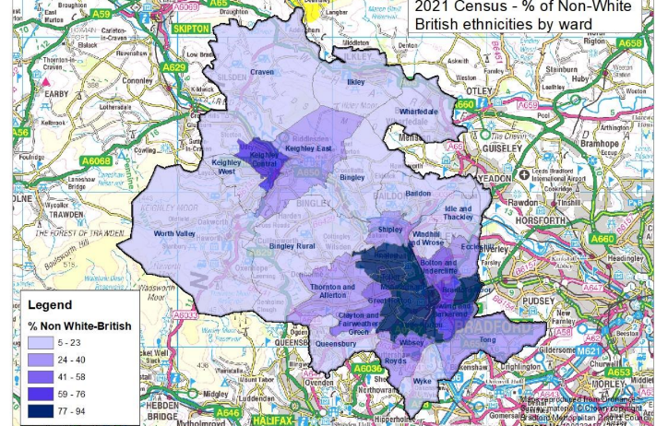
Bradford District Care NHS Foundation Trust’s Community Mental Health Teams (CMHTs) support adults with complex and enduring mental health problems across Bradford, Airedale, Wharfedale and Craven, for this review we will be looking at City CMHT. The service aims to ensure individuals are assessed, supported and treated appropriately to help them maintain or regain their place in the community and achieve optimal recovery. City CMHT hold around 400 appointments monthly for people with complex and enduring mental health problems who require specialist support. The team also works closely with and signposts to partner agencies and other NHS teams. Bradford City, Manningham and Toller wards cover a densely populated area with a population of around 65 000 people, neighbouring in the 2021 census, it was the most populated wards in the locality. The team take referrals from these and neighbouring areas.
If we look at the population of the area that City CMHT covers between 77 – 94% of the population is ethnically diverse. Taking City Ward as an example, 46% of the population is Asian or Asian British – Pakistani, 22% are White, 8% are Asian or Asian British – Indian and 8% are Black or Black British, 3% are Asian or Asian British – Bangladeshi, 7% are defined as ‘Other Ethnic Group which includes a growing Eastern European community.
In Toller 11% of the population is White and 75% of the population is Asian or Asian British - Pakistani.
Looking at referrals into the City CMHT by ethnicity 3.4% of referrals into the team have an unknown ethnic group. Asian or Asian British service users make up 52.3% of referrals, within this group, Pakistani service users are the largest subgroup, accounting for 41% of all referrals. The overall Bradford Metropolitan District local population the Asian or Asian British population is 23.3%. We might expect the referrals of Asian or Asian British people into the service to be higher given the population but it is difficult to compare when the service covers a broad area which does not align with ward boundaries exactly. It is an aspiration of the Business Intelligence team to align case load to ward level census data for further analysis. Through the assessment it has been identified that further work would be helpful to look at access to Community Mental Health Psychological Services by equality group to add another dimension to this work. This will be completed as one of the agreed actions. There are pilots planned to look at the access to Family Interventions in Psychosis and experience and outcomes of culturally adaptive Family Therapy which can be supported by this ongoing work.
Once referred, Asian and Asian British service users continue to engage with services at similar rates, representing 54.9% of appointments and 53.6% of discharges. Black or Black British service users comprise 3.5% of referrals compared to 1.8% of the BMDC local population but when we look at the ward representation of for example 3% in City Ward it is representative. This indicates a high level of engagement with mental health services among these ethnic groups.
A significant proportion of referrals (90.5%) come from areas experiencing high levels of deprivation, as measured by Index of Multiple Deprivation (IMD) levels 1 to 3. Appointment attendance and discharge rates for these service users are consistent with referral rates. Further analysis of deprivation domains reveals that most of the City CMHT caseload live in areas with high levels of crime and poor living conditions, alongside lower income and educational attainment compared to the wider population.
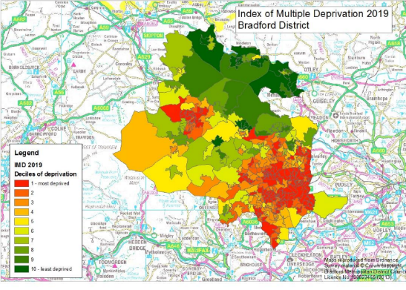
Assessing the religious makeup of the caseload is challenging due to incomplete data; religion is not recorded for nearly 55% of referrals. Among those with recorded information, Muslim service users represent the largest group at 26.5%, followed by Christian service users at 6.3%. If we take City Ward 2021 census data as an example 60% of residents are Muslim, 18% are Christian and 11% state they have not religion. 6% of resident did not state their religion.
Sexual orientation data is similarly limited, with 70% of referrals lacking this information. Where sexual orientation is known, 96% identify as heterosexual, while the remaining 4% describe themselves as homosexual, gay, lesbian, or bisexual.
The team have worked to support physical access to the building with a review of the waiting room to create a low stimulus space. There were examples of supporting patients to access the building for example, waiting downstairs in a quiet space, meeting within quiet consultation rooms, being met to support lift use for service users and carers.
Outcome 1B: Individual patients (service users) health needs are met | Score: 2
Evidence:
Approximately 27.4% of appointments are with a service user whose main spoken language is not English within their patient record. The team use an average of 50 face to face, 18 telephone and 5 video interpreting sessions per month. If we take two sample months (September and July 2025) the service access interpreting in 25 different spoken languages varying from month to month demonstrating the responsiveness to patient need. The team have worked hard to improve record keeping around language requirements so they can book ahead of time to meet the patients needs. The impact of having English as a second or other language or being a non-English speaker in therapy has been reviewed with a project plan to make improvements. Training for staff and interpreters in therapy models and using interpreters would be helpful to enhance current impacts.

Patient Related Outcome Measures (PROMS) are being introduced for all service users. In City CMHT the team are working to increase the number of service users with two or more measures so that the outcomes can be analysed. The Business Intelligence Team have aspirations to compare this data with IMD, Ethnicity, Sex, Sexual Orientation and Religion or Belief to give further EDI insights.
The care plan / assessment includes space to ask service users about identity and sense of self. Areas such as religion or belief and spirituality, sexual orientation and gender identity for example can be discussed as part of assessment, formulations and protective factor discussions in care planning. Having specific sections relating to this could enhance it along with training to support staff in having the confidence to ask about sexual orientation and religion. A suggestion was made to make the anti-racism framework and e-learning mandatory. The team share and refer service users to a range of specialist and voluntary and community services in response to this information. The team regularly utilise the Trusts Chaplaincy Service to support spiritual and Pastoral Care.
Personalised care is a priority to the team. Care plans are always tailored to service user need and through discussion with them. There can be a challenge with this when a patient is in crisis or has been referred straight from hospital as it can take time to connect, digest and develop trust with the service user and family. Discussion about EDI factors can feel a lesser priority unless they are obvious in these situations. The team work to develop this information and collaboration over time. They may for example leave the care plan with the person to give them time to consider their needs and how it might need to be recorded then work with them together to capture that. It was suggested that accessible or translated versions of the care plans would be helpful to develop.
Due to the location the team work in they are proactive to EDI needs. They have worked hard to be representative of the community so that they can better meet the needs of service users and are passionate about tackling health inequalities. The Multi Disciplinary Team are diverse in culture and background and are regularly called upon to advise and inform practice using their lived experience, knowledge and skills. There were many examples of the team working to support the wider needs of their client groups shared. Referrals were regularly made to VCSE and faith partners such as African community groups, South East Asian Women’s, Women and Men’s Groups, for support with housing, substance use, finance, education, safety etc.
There were examples of team lived experience being used to inform LGBT support for service users. Insights were used to address stigma and support onward referrals and support. There was awareness that due to the high proportion of Islamic and South East Asian service users other faiths and ethnic backgrounds could need further support development. Eastern European groups were identified as a priority.
The team have developed virtual tours of the CMHT Psychological Therapies service to improve access by helping service users, carers and other referring professionals better understand what to expect, reduce anxiety around referrals and support more informed decision-making. This is aimed at improving access for all service users but is beneficial to neurodiverse patients who may benefit from visualising where they are going and what will happen.
The CMHT Teams are involved in a Care Trust Way Service Improvement Programme which has enabled staff from across the service to come together to work intensively using data and stakeholder feedback to explore areas for development. Initial findings have found that when a selection of messages were put through Readability NHS checkers the reading age was 14+. The average reading age in the UK is 11, and in higher indices of deprivation areas such as the areas covered by City CMHT, 40% of adults have a reading age of 6-7 years. English is the predominant language used to communicate in writing which could create a barrier to communication for up to 20% of Bradford households (Census data from 2021 says that 83.1% of households have English as a first language for all adults). The benefits and considerations relating to text communication with patients is being explored through this workstream.
Staff raised concern about the delay it can take to get letters translated and sent to patients who do not read English. They want to enable families to read information around referrals, assessment and self care in a timely manner after appointments. The Patient Knows Best Digital Programme has introduced a tool that enables patients to sign up and access written information from the Trust in different formats and accessible ways. Launched in January 2025 4500 patients had signed up from pilot services by March 2025. Scope to roll this out across the Trust is being explored.
The team are aware of the potential for reduced access for some minoritised groups where knowledge of services, health literacy and stigma relating to mental health could be a factor. The team offer contact and support in different formats to encourage participation from under-represented groups within the case load. This includes opportunities for family work, providing consultation space in the community and new programmes like the ones referred to below.
Over the last 12 months Service Evaluation Projects for CMHT Assistant Psychologists have included
- co-production work to make our therapy agreements easy read and inclusive. There are plans to continue this work to look at existing templates and correspondence.
- A review of co-designing secondary mental health services with ethnically diverse communities.
The Service has introduced a new Group Therapy Approach called Stepping Stones in partnership with Mind Bradford:
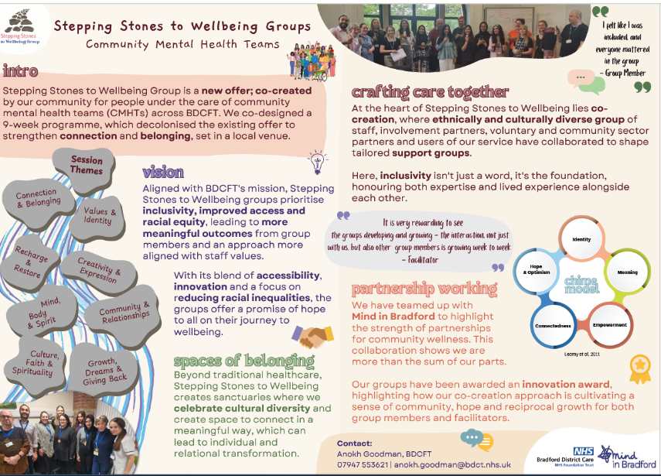
The outcomes for service users have been broad and sustained. Staff from both BDCFT and Mind have enjoyed the opportunity to work in this way reporting high levels of job satisfaction as a result of the collaborative approach. The programmme enables service users to connect and share their identities, growing in confidence and self-assurance.
Unfortunately, this programme will not be commissioned going forward due to the current financial challenges. The team would like to plan more coproduction opportunities in the future within the service to support the PCREF and to ensure that equality impact assessments are carried out in the planning, delivery and potential decommissioning of services.
Last year the Trust focused the EDS22 assessment the Physical Health and Wellbeing Service which provides physical health checks and support for service users with SMI. Over the last year the team have been working on their 2025 action plan which included introducing home visits for individuals who may face barriers attending clinic-based appointments and flexible options for blood testing, tailoring the approach to suit individual preferences and clinical requirements, further enhancing the personalised nature of the service. Working with the CMHT’s this has supported service users to engage and improve their physical health.
The Trust has committed to developing consistent neuroaffirmative practice approach and has established a Task Group to develop a strategic intent for this work. There is much good practice delivered within teams which will be collected and shared as resources across CMHT’s. An example of this work is the sensory checklist coproduced to reduce barriers to inclusion for people in therapy. These tools were piloted for three months in CMHT alongside the co-produced therapy agreement.

Training has been delivered with CMHT’s staff as part of the CMHT Transformation Programme during 2025 to provide opportunities for connection and exploration of culture and self-identity. This has been part of the Trusts Patient and Carer Race Equality Framework programme giving staff the chance to consider their culture, how culture shows up in day-to-day work life for them, their colleagues, our patients and communities and what impacts that can have on engagement, experience and impact of our care from an equality perspective.

Chaplains are available to support staff and service users in the team. We have four chaplains working with our mental health services. There is a Spiritual and Pastoral Care Policy and a new Multi Faith Reference Group which has CMHT staff in it. Members have contributed to the action plan to enhance and embed our Spiritual Care Action Plan. The team have made 14 referrals to the chaplaincy team during 2025. Training on accessing the team and spiritual care has been delivered to CMHT staff to increase referrals and use of the team. Themes of support have included intrusive thoughts experienced or expressed through a faith perspective, fears around possession or evil making them ill or out of control, rituals including repeated need to wash, pray or say words, a loss of faith of feeling of abandonment from faith. The team support to reduce isolation, connecting people with faith support or general spiritual care. The team feel they could do more in the City area if they targeted their support alongside spiritual care.

CMHT’s work closely with VCS Mental Health Partners to support patients’ needs being met effectively. Examples of programmes include SMI-LE (Serious Mental Illness Leadership and Engagement) in partnership with MIND in Bradford, Horton Housing and Inspire Bradford. Service users can access, flexible one-to-one support based on need, mental health, social, or welfare needs. They can access peer support, signposting, social prescribing, short-term support with housing issues as well as identifying wider needs for example, employment, bereavement, benefit support, money management, safeguarding. The team offer cultural and geographically specific support.

As part of the Trusts commitment to the NHS Patient and Carer Race Equality Standard Hope and Light has been commissioned and established over the last year to provide a culturally responsive mental health programme supporting Black African, Black Caribbean, Central and Eastern European (including Roma), and South Asian communities across Bradford District and Craven. The programme is built on lived experience, cultural understanding, and community collaboration to ensure services are inclusive, accessible, and meaningful. Services include:

- Peer support groups and healing circles.
- One-to-one culturally sensitive support.
- Inreach support for individuals transitioning out of inpatient care (hospital referrals only).
- Community-based wellbeing activities and workshops.
- Separate and mixed gender support for men, women, carers and LGBTQ+ individuals.
- Faith-informed services, including Islamic Psychology-based healing circles and the B-AM programme.

The programme brings together delivery partners from Bradford District and Craven Mind, Connecting Roma, African Caribbean Achievement Project (ACAP), European Drom, The Girlington Centre, Ihsaan, Inspired Neighbourhoods, Roshni Ghar, Staying Put, WomenZone, Yorkshire MESMAC
Outcome 1C: When patients (service users) use the service, they are free from harm | Score: 2
Evidence:
Over the past year, 22 patient safety incidents were reported. Analysis of the ethnicity data for these incidents shows that 54.5% of reports did not state ethnicity, 18.2% were Asian or Asian British, 13.6% were Black or Black British, 9.1% were White, and 4.5% were Mixed. The most common types of patient safety incidents were related to confidentiality and records (27.3%), followed by medication incidents or errors (22.7%). These findings have meant that information governance and medication safety remain priority areas, with a focus on reducing risk and strengthening processes.
The Incident System includes options for staff to report incidents relating to EDI, racial abuse, sexual safety and interpreting. These EDI metrics are analysed weekly with support offered to staff affected and management teams dealing with incident hotspots. There was one incident reported using the EDI Checkbox during 2025. There were no interpreting incidents reported during January to July 31st 2025. Within City CMHT, 5 incidents of physical violence or aggression where staff were affected and <5 were reported where service users were affected were reported over the last year (October 2024 – October 2025), no incidents of City CMHT staff or service users being affected by verbal or racial abuse during the period were reported. <5 incidents were reported where a member of staff was affected by sexual harassment. There was a feeling that incidents of racial abuse to staff from patients have increased. There was potential that this was due to a focus on zero tolerance and reporting but this needs to be investigated. The abuse has been from ethnically diverse patients to White staff and from White service users to ethnically diverse staff. The therapy team had offered spaces to reflect on this and international events that were affected the team and also service users and the community. The Trust has Managing Racial and Other Types of Abuse from Patients and the Public Policy and a Sexual Safety Policy both of which have associated training and staff intranet support repositories linked to them.
The service has health and safety, personal safety and risk assessment processes and procedures in place to safeguard patient and staff. These processes are within the Standard Operating Procedures. These are regularly reviewed and communicated.
Outcome 1D: Patients (service users) report positive experiences of the service | Score: 3
Evidence:
Between April to September 2025 the team received 178 responses to the Friends and Family Test (FFT). 74.2% responded saying the service was either ‘good’ or ‘very good’, while 15.7% responded ‘poor’ or ‘very poor’. Over 100 respondents praised staff for being compassionate, respectful, and attentive. Around 90 service users reported feeling listened to, empowered and well-supported in their recovery journeys, with some attributing life-changing improvements to the care received. Approximately 10 respondents highlighted cultural sensitivity and holistic approaches. Around eight respondents expressed dissatisfaction with medication management, lack of continuity and/or dismissive attitudes. Five respondents felt unsupported during crises, with safeguarding concerns and poor communication cited. Although the FFT captures details on peoples protected characteristics, it is currently unable to provide reports on this.
The team received thirteen formal complaints over the past year. Of the thirteen complaints, 8 did not have the complainants ethnicity recorded, 3 were white and two were mixed ethnicity. Learning complaints is reported and shared.
The Trust is developing an Ethnical Fellowship Programme for Involvement as part of the NHS Patient and Carer Race Equality Framework. The programme will be piloted in three mental health services in 2026.
Incidents, complaints and patient feedback are responded to promptly and there were examples of medics providing training and workshops to the team around cultural competence, spirituality and mental health and psychosis and attachment. The therapy team are proactive and very responsive in supporting the whole team to meet community need. The team have also reached out to VCS experts for training in response to feedback for example relating to LGBT communities and mental health.
There were examples shared of patients requesting a change of care coordinator or specific equality groups (faith and gender) which were a challenge to manage. This was a demonstration of personal choice straying into potential patients bias and questioning of staff abilities due to their background which would be a breach of the Trusts equality policies. The team consider the rationale for the request or feedback, investigate any concerns raised. If the request is reasonable and not founded on bias or discrimination they are considered. If not feedback would be given that no change would be made. There were examples of therapists offering mediation in these cases for the service user and care coordinator to support ongoing connection. The team shared that they would like more support in knowing how to escalate concerns around service user behaviour when it is discriminatory. They regularly send letters as per the managing discrimination policy but this does not always address the behaviour so would like support to agree what comes next.
The team are addressing health inequalities in collaboration with partners from the VCFS. This includes system wide projects that are community based alongside Inspired Neighbourhoods, Mind and the Cellar Trust. These engage with a wide community network of grassroots local organisations with reach into communities. The team described advocating, influencing and raising awareness for service users and mental health generally with other agencies, particularly housing, GP’s and physical health, within benefit systems and employment. They felt that when someone is in mental health services they could be judged on that and agencies might expect mental health services to provide additional support needed to access and navigate their systems. The team take a lot of time referring service users to local advocacy services to support this. It was felt that the way advocacy providers work has changed in the last five years moving to goal orientated provision. Housing, employment, income and physical health are wider determinants of physical health and the team felt mental health training and consideration should be given in all agencies to address mental health inequalities. One staff member explained that mental health nurses have physical health training as standard and that mental health training should also be given to non-mental health professionals. This will be picked up within the System Equalities Group.
Domain 1 – City Community Mental Health Service Overall | Score: 9

2021-census-ward-level-data-for-population-ethnicity-religion-and-household-composition.pdf
city-2024.pdf
city-2024.pdf

