**Workforce & Equality Committee Meeting**

**20.07.23**

|  |  |  |  |  |
| --- | --- | --- | --- | --- |
| **Paper title:** | NHS Workforce Race Equality Standard Update | | | **Agenda**  **Item** |
| **Presented by:** | Lisa Wright Head of Equality | | |
| **Prepared by:** | Lisa Wright Head of Equality | | |
| **Committees where content has been discussed previously** | | SLT 14.06.23  Strategic Staff Equality, Diversity and Inclusion Partnership 04.07.23 | | |
| **Purpose of the paper**  Please check **ONE** box only: | | For approval  For discussion | For information | |
| **Link to Trust Strategic Vision**  Please check **ALL** that apply | | Providing excellent quality services and seamless access  Creating the best place to work  Supporting people to live to their fullest potential  Financial sustainability, growth and innovation  Governance and well-led | | |
| **Care Quality Commission domains**  Please check **ALL** that apply | | Safe  Effective  Responsive | Caring  Well-Led | |

|  |
| --- |
| **Purpose of the report** |
| This report provides the 2023 NHS Workforce Race Equality Standard data for discussion and the relating action plan for approval. |

|  |  |
| --- | --- |
| **Executive Summary** | |
| There have been improvements across seven of the nine metrics, one metric has stayed static and one is not comparable in 2023 with previous years. There are still significant gaps in the experiences between Black, Asian and Minority Ethnic (BMAE) staff when compared with White staffs experience. For example, 8% less BAME staff feel there is fairness around career progression and promotion and 7% more BAME staff share that they have experienced discrimination from their colleagues or managers. Although there has been a reduction, BAME staff are still 2.87 times more likely to enter into a formal disciplinary than White staff. The Trust has established a WRES Task Group to deliver on the WRES Action plan presented for approval in appendix 1. | |
| Do the recommendations in this paper have any impact upon the requirements of the protected groups identified by the Equality Act? | **Yes** (please set out in your paper what action has been taken to address this)  **No** |

|  |
| --- |
| **Recommendation(s)** |
| The Workforce & Equality Committee is asked to:   * Note the data submitted to NHS England in May 2023. * Support and approve the action plan for publication on the BDCFT website. |

|  |  |
| --- | --- |
| **Relationship to the Board Assurance Framework (BAF)** | |
| The work contained with this report links to the following strategic risks as identified in the BAF:  **SO1**: Engaging with our patients, service users and wider community to ensure they are equal partners in care delivery (QSC)  **SO2**: Prioritising our people, ensuring they have the tools, skills and right environment to be effective leaders with a culture that is open, compassionate, improvement-focused and inclusive culture (WEC)  **SO3**: Maximising the potential of services to delivery outstanding care to our communities (QSC)  **SO4**: Collaborating to drive innovation and transformation, enabling us to deliver against local and national ambitions (Board)  **SO5**: To make effective use of our resources to ensure services are environmentally and financially sustainable and resilient (FBIC)  **SO6**: To make progress in implementing our digital strategy to support our ambition to become a digital leader in the NHS (FBIC) | |
| **Links to the Strategic Organisational Risk register (SORR)** | The work contained with this report links to the following corporate risks as identified in the SORR: |
| **Compliance & regulatory implications** | The following compliance and regulatory implications have been identified as a result of the work outlined in this report:   * Equality Act 2010 * NHS Equality Delivery System 2022 * NHS Workforce Disability Equality Standard * NHS Workforce Race Equality Standard |

**Workforce & Equality Committee Meeting**

**20.07.23**

**NHS Workforce Race Equality Standard Update**

**1 Purpose**

The Workforce Race Equality Standard (WRES) is part of the NHS Standard Contract and supports NHS organisations to be compliant with the Equality Act 2010 and the 2017 Regulations. The WRES was launched by NHS England in July 2015. Bradford District Care Foundation Trust (BDCFT) has been publishing data against the WRES metrics annually for six years and has collected data in August every year since 2014.

The implementation of the WRES is an Equality Objective for the Trust. The Equality Objectives run from 2020-2024 and are a legal requirement to have under the Public Sector Equality Duty.

The Belonging and Inclusion Plan was approved at Trust Board in October 2021 and will run until 2024. The plan includes the Trusts priorities and what commitments are made to improve the Trust’s performance against the NHS Workforce Race Equality Standard.An EDI Strategic Staff Partnership scrutinises and supports implementation. A Workforce Race Equality Standard Task Group is also in place to drive change around the WRES priorities.

The data collected for the WRES was submitted via the Strategic Data Collection Service (SCDS) NHS Digital database and the DCF online platform in May 2023. This report outlines the headlines from that submission, the comparison, and trends over the previous years and the actions that will be and already have been embedded into the Belonging and Inclusion Plan. The intention is that this report is published as evidence on the BDCFT website. Publication is a key element of compliance with the Public Sector Duty of the Equality Act 2010

In addition to these established standards NHS England have developed two new standards this year. They are the Medical Race Equality Standard and the Bank Staff Race Equality Standards. Both launched with options for voluntary submission in 2023 by the end of June. The organisation has collected the available data for both standards to be shared and discussed at the Workforce and Equality Committee in October but has not submitted this during this test year. The Trust will submit the data by May 31st, 2024.

1. **Proposed Outcome**

There have been improvements across seven of the nine metrics, one metric has stayed static and one is not comparable in 2023 with previous years. There are still significant gaps in the experiences between Black, Asian and Minority Ethnic (BMAE) staff when compared with White staffs experience.

The table below presents the 2023 WRES data taken from the Electronic Staff Record on 31st March 2023 and Human Resources records over the reporting period.

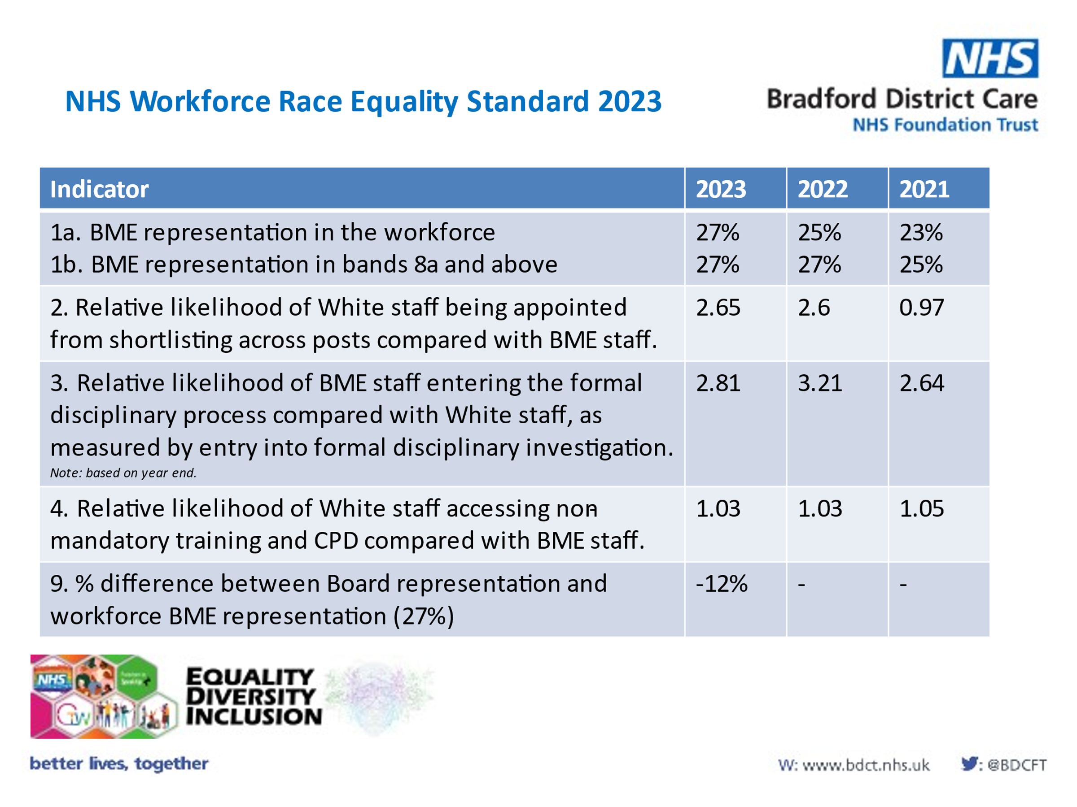

National benchmarking data is not yet available for 2023 but will be presented alongside the BDCFT results for comparison once issues.

The Trust has equal representation across senior bands when compared with the whole organisation which is an excellent achievement. NHS England identified BDCFT as a national case study for success in this area in 2022/3. The population of Bradford has changed with the BME population increasing from 36% in 2011 to 43% meaning the workforce is still under-representative of the local ethnic diversity.

Reducing the likelihood of BME staff entering into a formal disciplinary and increasing the likelihood of BME staff being appointed after shortlisting are still key priorities for the WRES Task Group.

The table below shows the 2022 NHS staff survey WRES indicators.

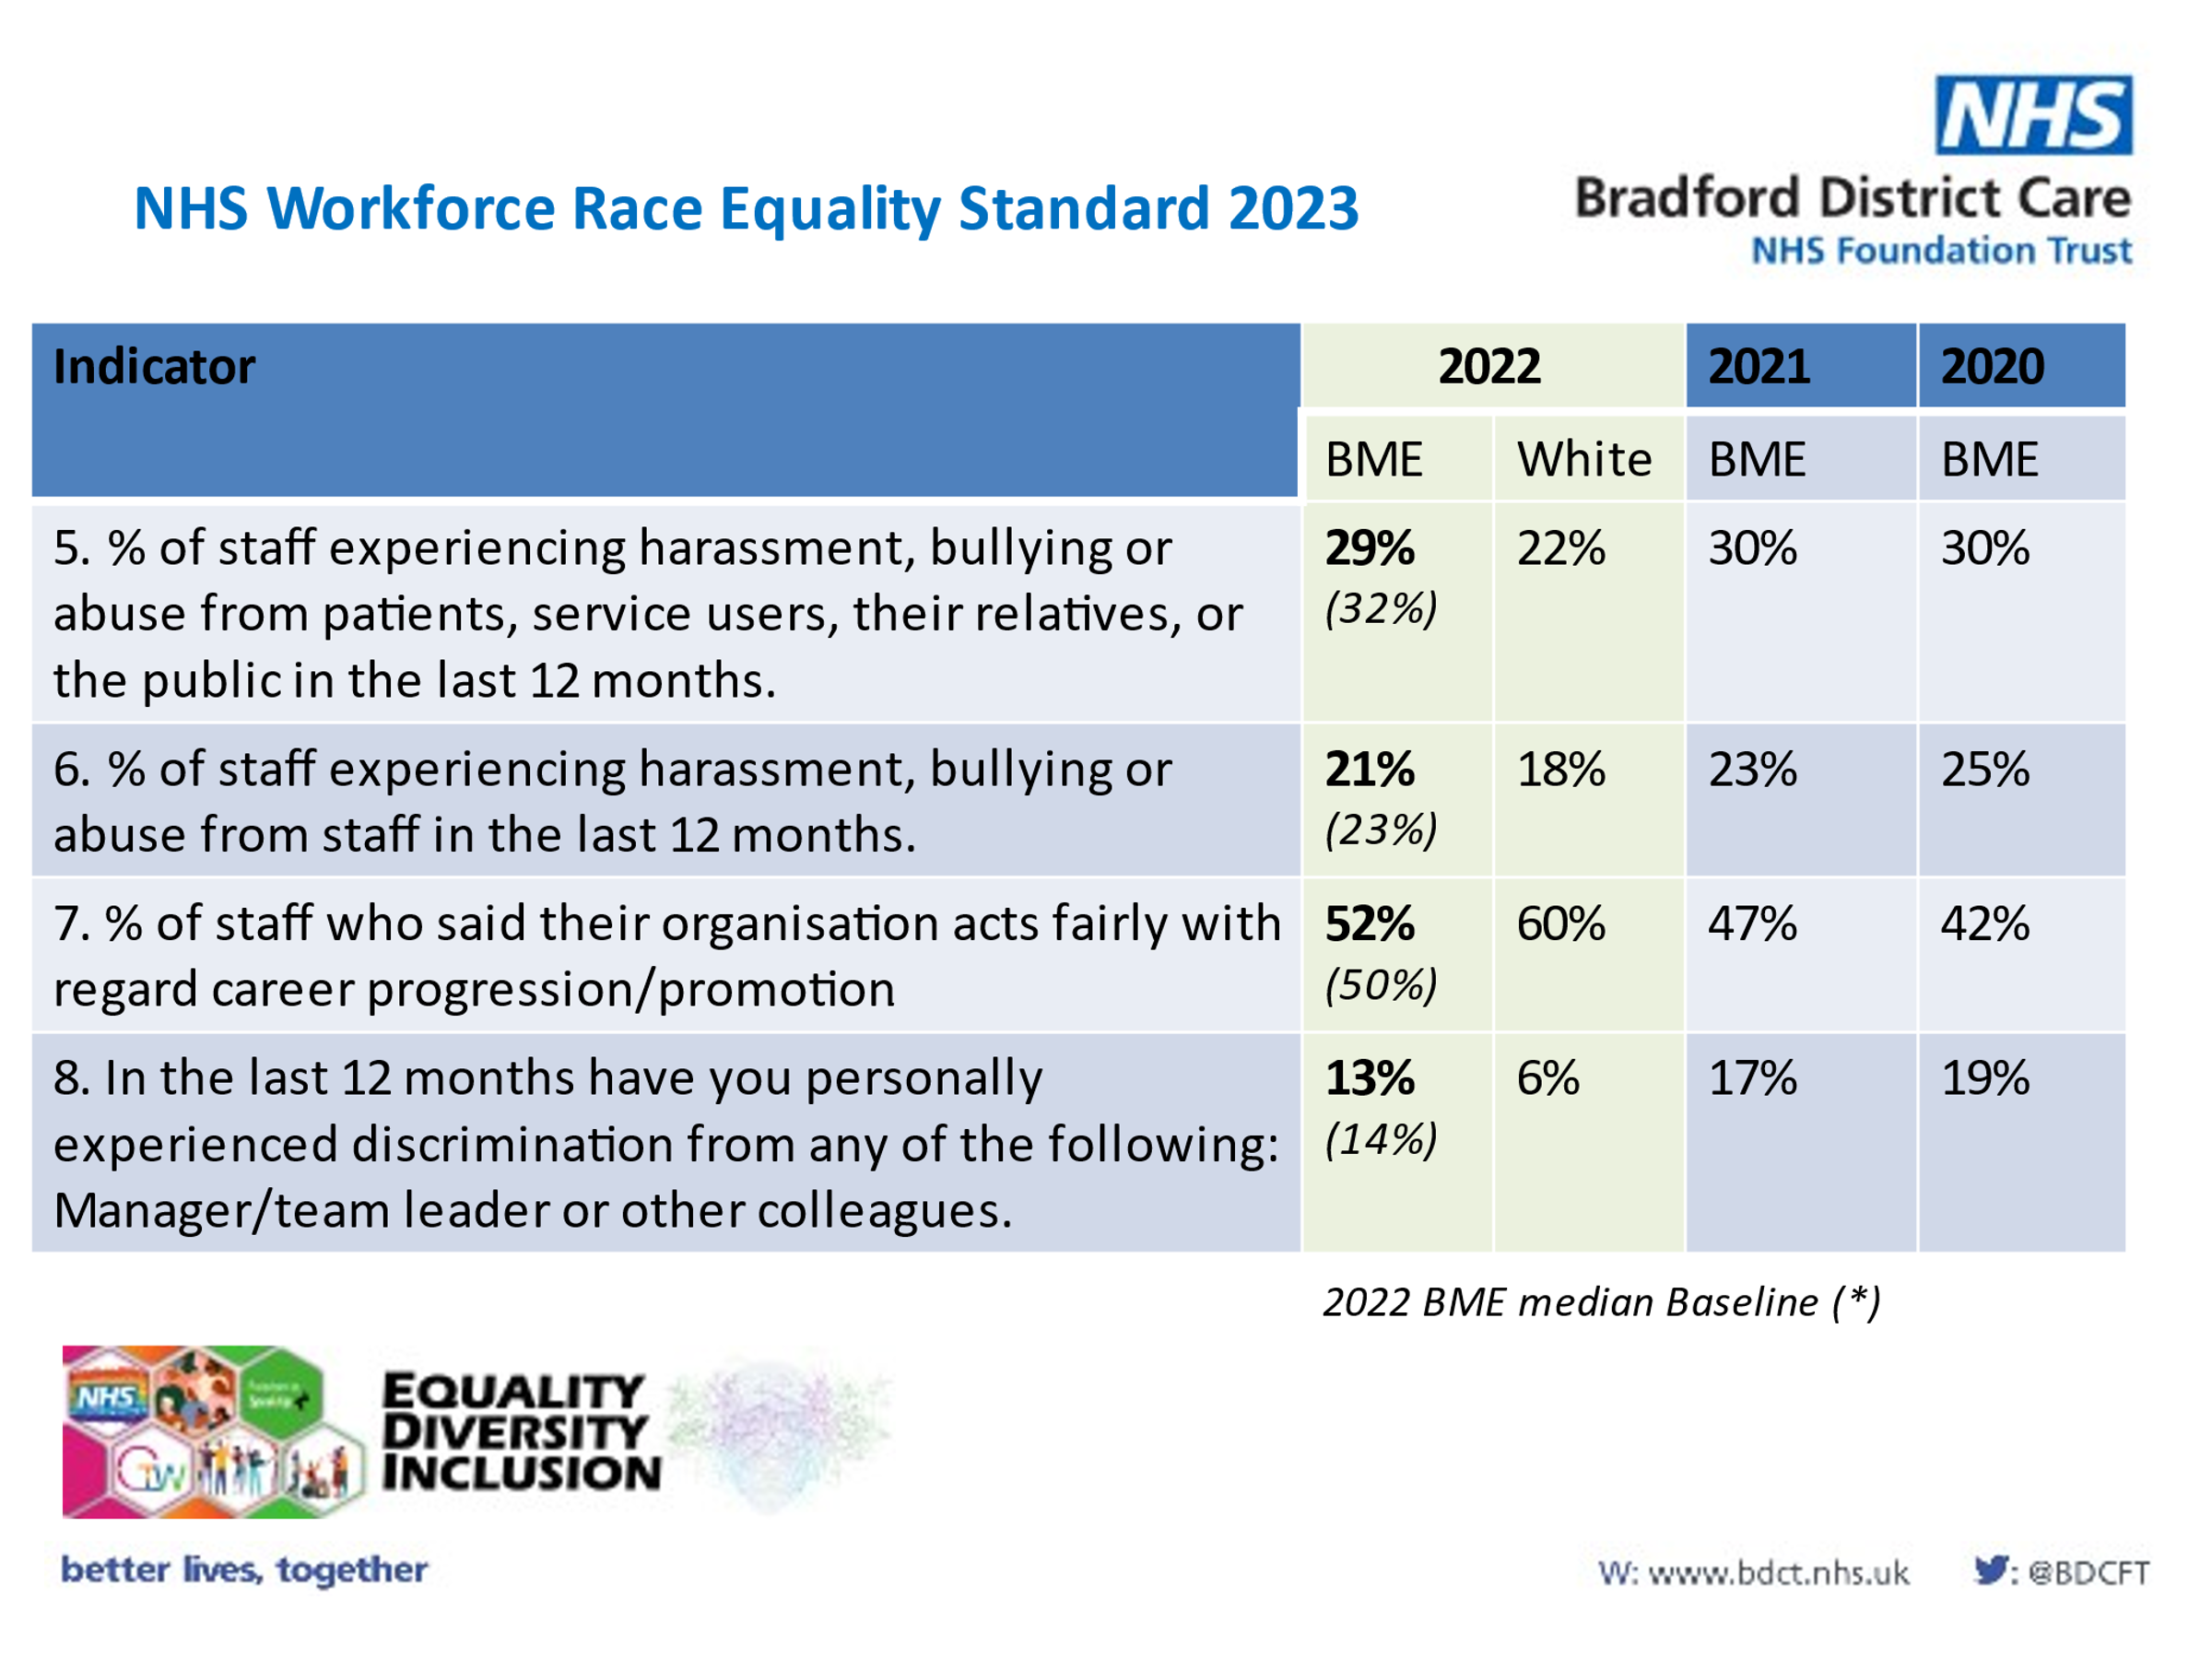

The staff survey data suggests that there has been a 1% reduction in BME staff experiencing harassment, bullying or abuse from patients or the public and that the Trust is performing 3% below the benchmarked average for this indicator.

There has been a reduction in BME staff reporting they have been bullied, abuse or harassed by staff, managers, team leaders and colleagues. The Trust is also above the national performance benchmark for these metrics. There is still a significant gap between White and BME staffs experiences pf abuse across all metrics.

2% more BME staff than the national benchmarked average feel the Trust acts fairly regarding career progression and promotion this is a 5% increase since 2021. There is an 8% gap in the perception of White and BME staff relating to this metric.

1. **Options**

A detailed action plan is included in appendix 1. The following are key priorities for 2023/24.

* Despite the reduction in abuse figures shown through the WRES metrics there is concern that abuse is under-reported within risk systems. A programme of work to ensure staff are accurately identifying and reporting incidents is underway. This will be triangulated with staff survey data to inform WRES plans and interventions.
* A programme of work to reduce the disciplinary likelihood score is underway including the establishment of a set of management competencies and associated training and development offers.
* A project to increase visibility of the wellbeing @ work support available to BME staff working in In Patient Mental Health settings is being established.

**4 Risk and Implications**

The Trust aims to be the Best Place to Work for all. Inequalities in experience of working in the Trust are a key priority to reduce. Research shows[1] that equality of experience in the workforce has a direct correlation with quality of care, innovation and compassion. Bradford has an incredibly diverse ethnic population and having an inclusive workforce that reflects that community enables culturally appropriate services that are right first time.

**5 Results**

This information has been shared at the Senior Leadership Team in June 2023 and the Strategic Staff EDI Partnership in July 2023. Further reports on progress will be taken to these groups over the next six months with a formal update coming to the Workforce and Equality Committee as part of the Belonging and Inclusion Plan in October 2023.

**Lisa Wright**

**11.07.23**

**Head of Equality**

1. [Equally outstanding: Equality and human rights - good practice resource, November 2018 - Care Quality Commission (cqc.org.uk)](https://www.cqc.org.uk/publications/equally-outstanding-equality-human-rights-good-practice-resource-november-2018)