Health & Hospital passport

This VIP Passport gives health and hospital staff
important information about you.
Please provide as much information as possible to help the hospital staff meet your specific needs.
This is not a formal assessment or care plan.

My NHS number:………………………………………………………………………………. Version 4 March 2026
 | My full name is: ...........................................................................................  I like to be called: ........................................................................................
 | My religious needs are: ................................................................................  My ethnic background is: .............................................................................
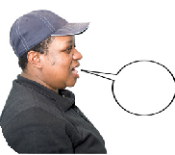 | Language/s I speak: ............................ Understand: ....................................  Language/s my carer speaks: ....................... Understands: ............................
 | Tell us the things you like to do and talk about: | Tell us what you don’t like to do or talk about:

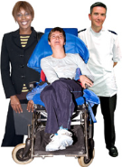 | Other services involved with me… For example, social services, other health services, other  Please list all and provide telephone numbers
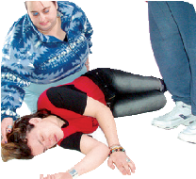 | Tell us your medical conditions and anything else we should know about your health
 | Allergies or sensitives?
  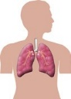 | Tell us about any operations?
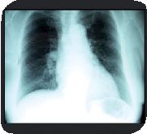 | Tell us the best way to support you to have medical interventions
 | Are you scared of needles and how can we help you?
 | How do you take your medication? For example, crushed, injected, syrup, with food, other.  Please bring a list of the medication you are taking now.
 | Tell us any reasonable adjustments you need in hospital?
   | Tell us about your hearing/sight:

All about me
     | Tell us how you communicate?  How do you express worry or anger and how can we help you?  How do you show signs of pain verbally?  And non-verbally…  How do you express worry or anger and how can we help you?
 | What can we do to help you understand decisions you need to make about your health? Remember Mental Capacity Act. For example, easy read leaflets or using videos or having someone familiar to support you.

Mental Capacity Act 2005 – For people ages 16 or over
If a person is assessed as lacking the ability to make a decision and needing an advocate, please follow local Mental Capacity Act Policies and Mental Capacity Act Code of Practice. If I am assessed as lacking the capacity to consent to treatment, the following people must be involved in any decisions made in my best interest.
Name | Relationship | Contact Details

Do you have lasting Power of Attorney or Deputyship? Yes No

This is a legal document that lets you appoint someone to help you make decisions.

Name, Relationship and contact details
Eating and drinking
 | What do we need to know to support you eating, do you have a specific plan or use special equipment?  Foods I like: .................................................................................................  Foods I don’t like: ........................................................................................  Special diet: ......................................................................................................
 | How can we support you to drink, do you have a plan or any equipment needs?  ....................................................................................................................  Drinks I like: ................................................................................................  Drinks I don’t like: ........................................................................................  Specific risks associated with choking:

 | How can we help with your personal care?
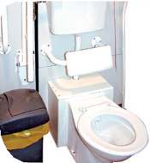 | Tell us how to support you with going to the toilet or meeting your continence needs?
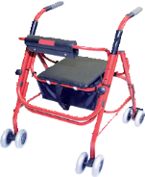 | Tell us about your mobility and any specific needs you have?
 | Tell us what we need to do to help keep you safe:
Personal Care
Leaving hospital

 | When planning for you to go home, who do we need to talk to and what things should we consider?
 | Do you need support to get home from hospital?  Yes No
I consent to share my passport with health professionals supporting my care and treatment which includes printing a copy for staff to read:
Signature………………………………………………………………..Date:……………………………….

Or a best interest decision has been made because I lack capacity:
Date…………………………………………………………………………………………………………
Signature/designation………………………………………………………………………………
Completed by Name and Role…………………………………………………………………..

Documents to bring with me to Hospital
 | Respect  Who to ask about this e.g. GP  I Have I Don’t Have
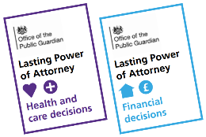 | Lasting Power of Attorney/Court Appointed Deputy  Who to ask about this e.g. GP  I Have I Don’t Have
 | Advance Decisions  Who to ask about this e.g. GP  I Have I Don’t Have
   | List of Medications and any other health information  Who to ask about this e.g. GP  I Have I Don’t Have
 | Speech and Language recommendations/guidelines  Who to ask about this e.g. GP  I Have I Don’t Have
 | Positive Behaviour Support Plan  Who to ask about this e.g. GP  I Have I Don’t Have
 | Communication Aid/Recommendations  Who to ask about this e.g. GP  I Have I Don’t Have
 | Respiratory Care Plan  Who to ask about this e.g. GP  I Have I Don’t Have

