Helping with understanding

User guide:
Active Listening for Active Learners

The  intervention | Active Listening for Active Learners  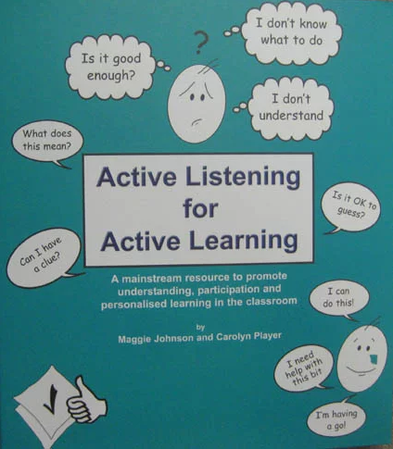
Where to find it?  How much  does it cost? | Digital Resource (ALFAL) | Course Beetle  The cost of the resource is £75 for a 3-year online subscription.
What does it target? | The intervention targets the skill of ‘active listening’ or comprehension monitoring. Active listening is the skill of:  - Recognising when you haven’t heard properly and / or don’t understand,  - Actively seeking to put this right.  Many children with SLCN will find it hard to ‘keep track’ when listening in the classroom. This resource will help them to:  - Recognise when they haven’t heard properly and / or don’t fully understand.  - Tell the other person when there is a problem.  - Attempt to ‘fix’ the communication breakdown themselves (actively seek clarification).  The aim is to teach children to recognise what they do and don’t understand and give them some strategies to respond when they don’t understand what’s being said. Many children with speech, language and communication needs struggle with this skill and need direct teaching to develop it.
Who is it for? | The resource was developed for children aged 4-12 years. It has been used with older students.  A child or young person may benefit from support with their active listening if they:  - Are very passive in the classroom.  - Struggle with independent work.  - Constantly check they are doing the right thing.  - Say nothing or say too much (go off at a tangent).  - Guess all the time.
What is it? | The programme is a six-part resource;  - Creating a safe listening environment.  - Further investigation and planning.  - Linking language to social interaction.  - Concepts to understanding and knowledge.  - Developing classification skills.  - Maintaining active listening skills.
How does it work? | The programme can be used as whole school/whole class approach. It can also be used to support individual education plans and provide additional activities for pupils who need support with their active listening skills. It can be used with individual children or small groups.
Who can deliver it? | Either a teaching assistant or teacher.
How long does it take? | The programme can be used flexibly depending on the child’s needs and available resources.
What resources do I need? | The programme provides session plans and all resources required to run the intervention.
How do I show progress? | Pre and post assessment can be completed as part of the intervention.
Top tips | Whole class strategies:  - Expect questions: remind children they won’t understand everything, and that you expect them to question.  - Practice: give practice in dealing with impossible words, requests and instructions.  - Mistakes are good: remind children that making mistakes is important for learning (Growth Mindset).  - Positive: respond positively to all requests for information, even when this has been repeated several times.
Additional  resources | A five-minute video overview is available here:  Active Listening for Active Learning — Therapy Ideas Live - Bing video  Training is available online from the author Maggie Johnson here:  https://www.qed.uk.com/maggiejohnson
Evidence  base | The link below discusses the evidence. In summary ‘The comprehension monitoring approach has a moderate evidence level. Within the evidence are examples of significantly positive outcomes for children with language impairments. It is therefore a useful approach to implement where appropriate’.  Active Listening for Active Learning (ican.org.uk)

