Health Awareness Campaigns Summary
2022-23

Each year the Library and Health Promotion Resources team for BDCFT, with support and guidance from MyLivingWell, coordinate six health awareness campaigns across Bradford and Airedale. Campaigns involve the distribution of display packs containing leaflets and posters on specific health topics; we also do this online via our website, on Twitter and our email networks with key campaign messages and digital resources available for download.

Our campaigns are collaborative, and we welcome the support of organisations in disseminating our campaign messages. The campaigns aim to coordinate public health efforts across the district, allowing many different partner organisations to work together, sharing common goals and ensuring that all people across our district have access to health information which can support them.

To join our email list, to keep up-to-date on the latest health awareness campaigns, please email library.lynfield@bdct.nhs.uk or go to https://www.bdct.nhs.uk/working-for-us/library-health-promotion-resources/health-awareness-campaigns/. Also see @BDCFTLibrary on Twitter.

Campaign Topic | Dates
Mental Health Awareness Week | May 9th - 15th 2022
Kids’ Physical Activity | September 2022
Stoptober: Smoking Cessation | October 2022
Self-Care | November 2022
Dry January | January 2023
Anxiety & Stress Awareness | March 2023

- Mental Health Awareness (national campaign)

Date: May 2022

Resources included: 2 x A4 Swaps to get you up and about (C4L) double-sided posters
3 x How Are You? (PHE) Z cards
2 x A6 Understanding Physical Activity (BHF) leaflets
2 x Discover simple steps to look after your mental health (Better Lives) Z cards
1 x Briefing sheet

Campaign Packs delivered by Royal Mail to: 88 GP practices & health centres in Bradford, Airedale, Wharfedale and Craven.

Additional campaign resources available from: LMH Library

Display photo
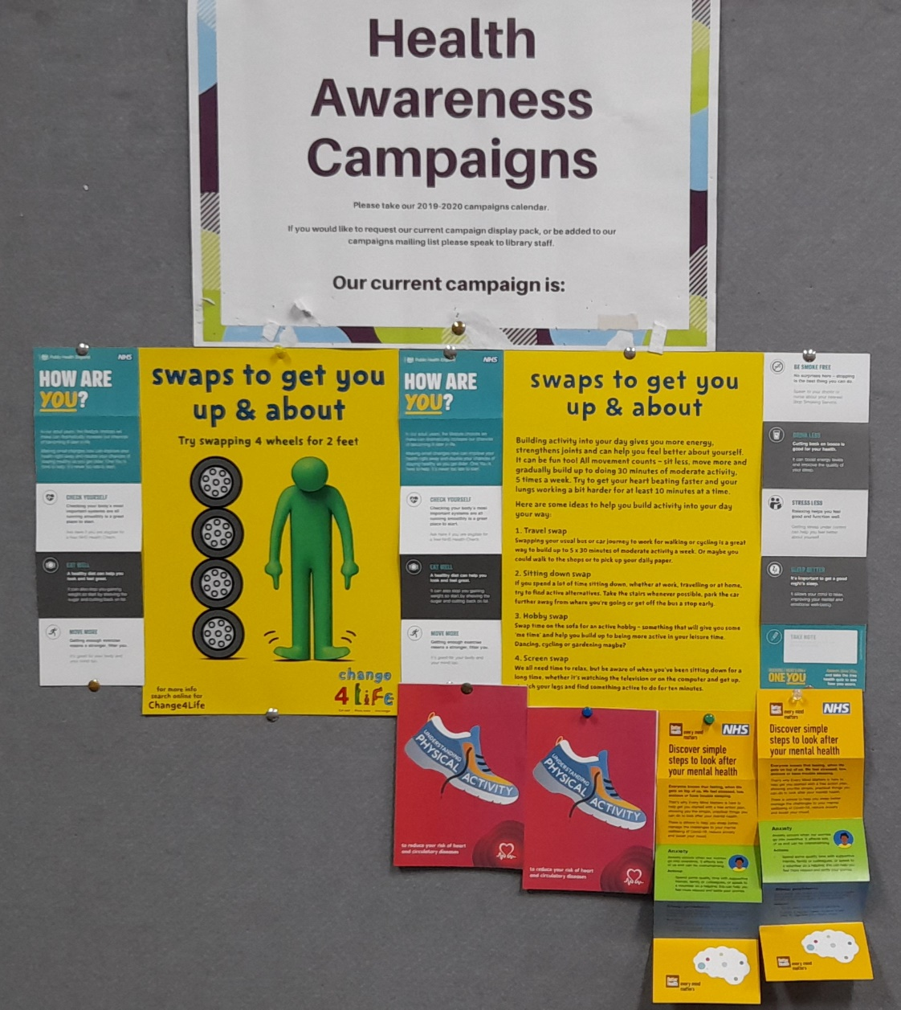

- Kids’ Physical Activity campaign 2022

Date: September 2022

Resources included: 2 x A4 Shake Up your Summer! (C4L) different posters
1 x A3 Shake Up your Summer! (C4L) poster
2 x Shake Up (C4L) activity packs
1 x Briefing sheet

Campaign Packs delivered by Royal Mail to: 88 GP practices & health centres in Bradford, Airedale, Wharfedale and Craven.

Additional campaign resources available from: LMH Library

Display photo
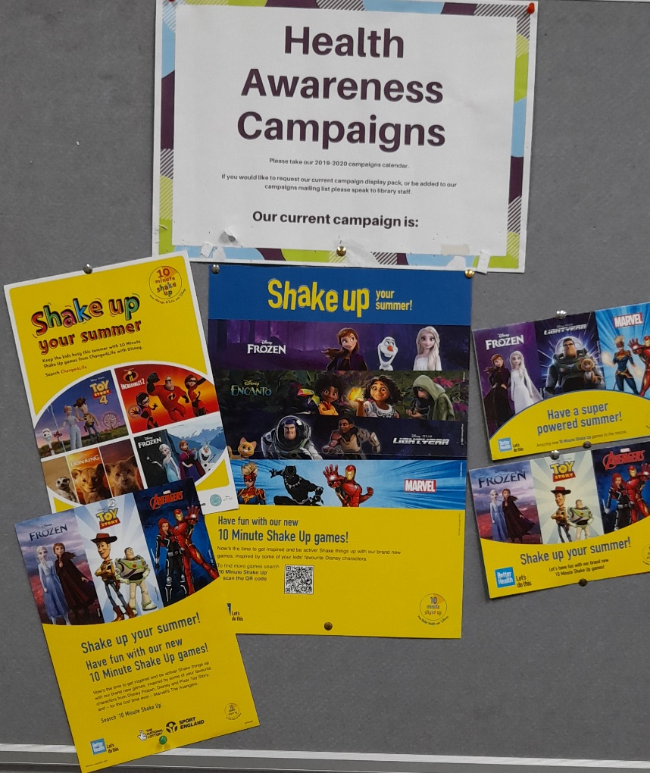

3. Stoptober (NHS national campaign)

Date: October 2022

Resources included: 2 x A5 There’s never been a better time to quit leaflets
2 x A3 Stoptober (official campaign) different posters
3 x Quit Smoking (NHS Better Lives, Z cards)
1 x Briefing sheet
Tweets: https://twitter.com/BDCFTLibrary/status/1574507854886711296?s=20&t=Y69F_iWiyjoV6CWzEa5dUQ

Campaign Packs delivered by Royal Mail to: 88 GP practices & healthcentres in Bradford, Airedale, Wharfedale and Craven.

Additional campaign resources available from: LMH Library

Display Photo
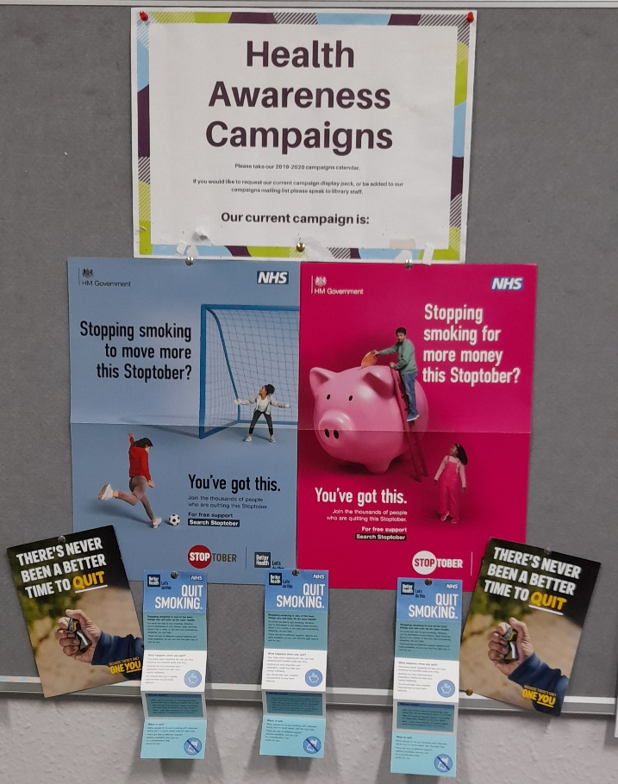

- Self-Care Week (Self -Care Forum national campaign)

Date: 14-20 November 2022

Resources incl: 2 x A4 Swaps to get you up and about (C4L) double-sided poster
1 x A4 Exercise Self-Care for Life (official campaign) poster
2 x A6 Understanding Physical Activity (BHF) booklets
2 x How are you? (PHE) z cards
2 x Discover simple steps to look after your mental health (NHS) z cards 1 x Briefing sheet

Tweets: https://twitter.com/BDCFTLibrary/status/1592087442638503941?s=20&t=xfod5Mm4XuVgVQncPtCK5w

Campaign Packs delivered by Royal Mail to: 88 GP practices & healthcentres in Bradford, Airedale, Wharfedale and Craven.

Additional campaign resources available from: LMH Library

Display Photo

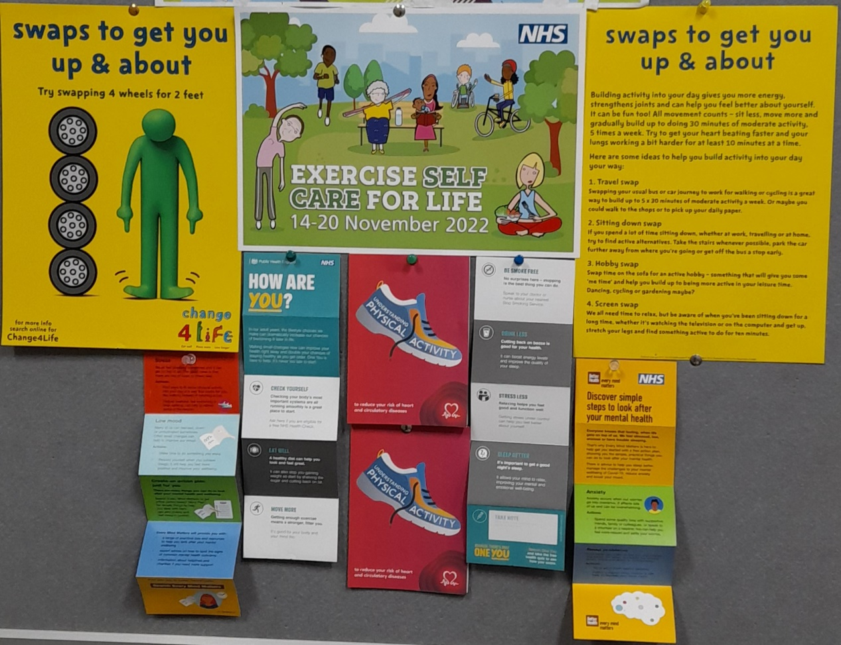

- Dry January Alcohol Change (national campaign)

Date: January 2023

Resources included: 2 x A4 Alcohol Change posters (different)
1 x A3 Drinkaware poster
2 x A6 Understanding Alcohol (BHF) booklets
1 x Briefing sheet

Tweets: https://twitter.com/BDCFTLibrary/status/1601220754283982850?s=20&t=P-RoYI4MJa5QUv0-JyKKqA

Campaign Packs delivered by Royal Mail to: 88 GP practices & healthcentres in Bradford, Airedale, Wharfedale and Craven. Additional resources to Willows M/P (Queensbury).

Additional campaign resources available from: LMH Library

Display Photo

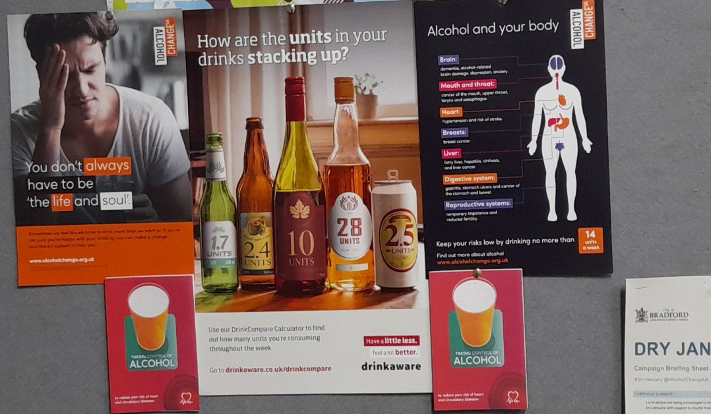

- Anxiety & Stress Awareness Campaign

Date: March 2023

Resources included: 2 x A4 Top Tips to Improve Your Mental Wellbeing posters
2 x A4 Take a Moment posters (different)
1 x A4 10 Keys to Happier Living (MHF)
2 x A6 Understanding Stress (BHF) booklets
1 x Childline contact mini-card (primary)
1 x Childline contact mini-card (secondary)
1 x Briefing sheet

Tweets: https://twitter.com/BDCFTLibrary/status/1627971995408207872?s=20

Campaign Packs delivered by Royal Mail to: 88 GP practices & healthcentres in Bradford, Airedale, Wharfedale and Craven.

Additional campaign resources available from: LMH Library

Display Photo

