YOUNG PEOPLES EVENT – HELD AT BRADFORD CITY FOOTBALL GROUND
OCTOBER 2017

PATIENT EXPERIENCE AND INVOLVEMENT TEAM - Feedback

Our team took a stand at the event and decided to use this opportunity to hear from the young people on two particular topics shown below. The outputs were interesting and we think that these may be useful to share in relation to what the young people said about services they had experienced, and, relating to their preferred method of contact when asking for feedback – read on ....

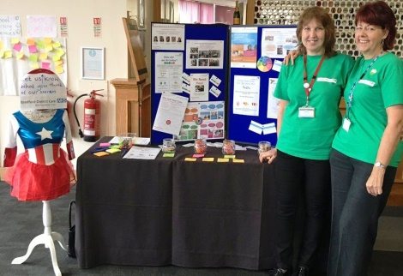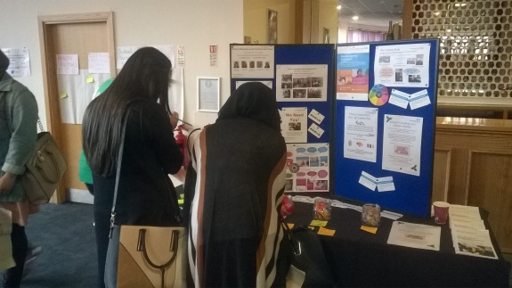

WHAT we wanted to know:
1. What is your experience of these Trusts’ services specifically School Nursing; Health Visiting; Dental service?

2. What would your preferred contact method be if we wanted to gather their feedback on services in the future.

HOW we did it:
We attracted the attention of the young people by having bright display boards, a mannequin dressed as a superhero, free sweets, free coloured pens and we actively encouraged the young people to speak to us by approaching them and telling them about the freebies

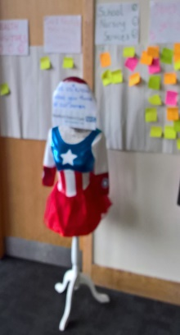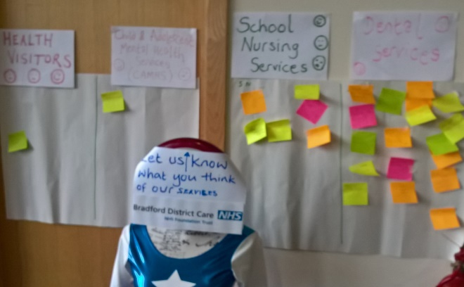

We explained to them what we do and about how we work to involve people in the work of the Trust to help us to deliver the right service at the right time, and that getting feedback from our users was really important, and then asked them to help us with the two items highlighted above.

Q1. Can you tell us what you thought of your experience of these 3 services:
We offered them fluorescent sticky notes and a free fluorescent pen (to keep) for their input. The results are written up in the PDF file here – its interest stuff – please open and read this PDF

Q2. If we wanted your feedback after you’d used one of our services, what would be, for you, the best way to do this and the one which you would be most likely to respond to?

The choices were :
- Smartphone
- Face to face (ask you there and then)
- Give you a paper form to complete
- Via a video box or similar

The method of voting was by removing a sweet from the jar marked which showed their preference for how to be contacted. The enticement was that “you can eat the sweet” . Whichever jar was emptied the quickest showed the majority preference and would also show ranking of other methods. The results were quite surprising. The picture was taken part way through the event.

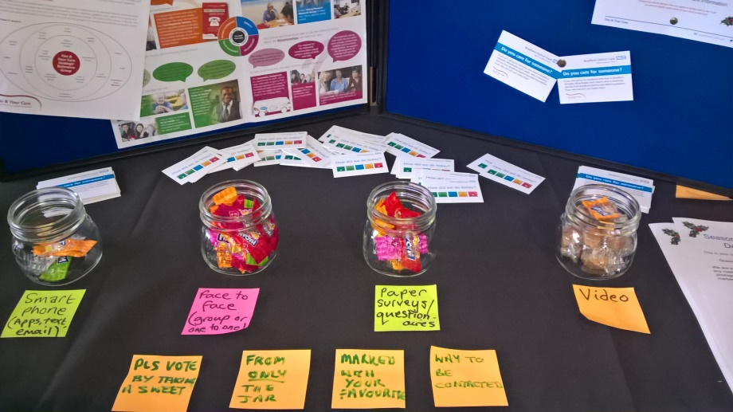

- The first choice was as expected, contact via Smartphone;

- The second choice, which was the surprising one, was to be given a paper form to complete and return. The rationale given by many of the young people was that they get so many things coming to them via their phones that they would be more likely to ignore it, whether on purpose or just by overlooking it in the mass of other things. They also commented that having a paper form felt somehow more important and that “someone” would take notice / action.

- Face to face and being asked directly for their feedback was third choice

- The video box idea didn’t seem to be of interest at all – another surprise to us.

We hope this was useful, if you have any further questions or queries or would like to more please don’t hesitate to contact the Patient Experience and Involvement Team.

