Please tick

**Consent to Share Your Recovery Story**

I consent to my recovery story being used in the recovery stories booklet for other service users and kept on the Early Intervention shared drive

I consent to my recovery story being used in the recovery stories booklet and given to people outside of Early Intervention

I consent to my recovery story being used to evaluate Early Intervention

I consent to my recovery story being used on the Early Intervention website in the future

Signed:

Print name:

Date:

Witnessed:

Print name:

Date:

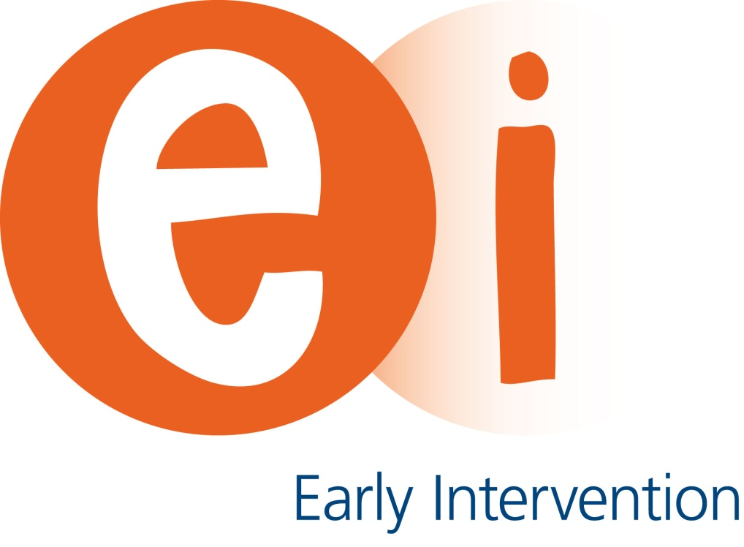

**Recovery Stories**

**You and Your Care**

Published: Date July 2014 Review Date: Date July 2015 Pin: 00433



Bradford and Airedale Early Intervention Service

Culture Fusion

Bradford

BD1 2EP

**Tel** 01274 221022 (please ask to speak to the Early Intervention service)

**www.bdct.nhs.uk**

Giving consent (or not)

Before you agree to your recovery story being used, we would like to explain how it could be used. As well as reassure you that you can withdraw your consent at any time, even if you give it to begin with. We can also ensure that your name is anonymised should you wish.

* The recovery stories booklet is kept on the Early Intervention shared drive. This shared drive can only be accessed by those who work for Early Intervention. Early Intervention workers can then print a copy of the recovery stories booklet to give to a service user who they think would find beneficial.
* Early Intervention would also like to use the recovery stories booklet for health promotion and education purposes. This could mean for example, other health providers or schools could be given the recovery stories booklet to increase their awareness and knowledge of the difficulties that people can face as well as see the work that Early Intervention does. The booklet would be given out at the discretion of workers.
* The recovery stories that are written can also provide us with important information – for example, things that have helped (or not) and what Early Intervention has done that has been helpful. This information would be used anonymised to extract themes that would help us evaluate our service.
* In the future, Early Intervention also hopes to have a website. This website would be for service users to see, as well as give information to the public, professionals and those who offer to support to people experiencing psychosis or concerned that somebody they care for may need some help. We would hope to have some recovery stories on this site.

We appreciate that this can be a big decision to make and before you give your consent, you may wish to take some time to think it through. If you decide that you would like to be part of the recovery stories project, there is a consent form overleaf which we would like you to fill in and be witnessed.

Recovery stories

Recovery stories are often a good way for service users to see how far they have come, see how they have developed, look at how they have coped and dealt with their difficulties.

People’s lives are shaped by events that happen and part of our personal development is making sense of what has and is happening. Having a safe place to explore these things can help us feel empowered, progress with our journey and give us a fuller view of events that have happened in our lives and the impact of these events and experiences.

Writing your own recovery story

Early Intervention would like to offer you the opportunity to produce your own recovery story. It may be something you prefer to do by yourself, or you may wish to have the support of someone from Early Intervention (either someone you know or one of their colleagues) – the choice is yours.

Our recovery story project is not just about writing!

We are able to offer alternative methods of producing a recovery story through painting, film, photography, music, poetry and animation as well as the opportunity to be interviewed about experiences which can then be transcribed or kept as a sound file. If you choose to write a recovery story, it may be something that you want to keep to yourself or share with others.

Sharing your recovery story

Early Intervention currently has a recovery story booklet, containing individual’s stories who were keen to share them with others. This booklet is given to other service users who have recently begun to have difficulties, or at times of increased difficulty and crisis. Reading other peoples stories can help service users see there is hope and can help them to learn from others who have come through such tough times.

The Early Intervention Service values the experiences of our service users and if you chose to produce a recovery story and decide to share it with others, we would like to ask your consent to use the recovery story that you have written.