BOARD MEETING

26 NOVEMBER 2015

Paper Title: Chief Executive’s Report
Section: Public
Lead Director: Simon Large, Chief Executive
Paper Author: Paul Hogg, Trust Secretary
Agenda Item: 7
Presented For: Discussion

1. Purpose of this Report:

The purpose of this report is to update Board members on national, regional and local issues, announcements relating to mental health, learning disability and community health services and Chief Executive level discussions within the local health economy.

2. Summary of Key Points

The key elements in this report are:

- Proposed changes to the frequency of CPAs; and
- NHS England’s report into the proposed reduction in LD inpatient beds.

3. Recommendation:

That the Board:

- Agrees to note the content of the report and identifies any other items that require further discussion at the Board meeting itself.

4. Financial Implications

None.

5. Legal Implications

None.

6. Equality Impact Assessment

Not applicable.

7. Previous Meetings/Committees Where the Report Has Been Considered:

Highlight whether the paper has been discussed at any of the following meetings by placing a tick in the relevant box(es):

Audit Committee |  | Quality & Safety Committee |  | Remuneration Committee |  | Finance Business & Investment Committee
Executive Management team | √ | Directors’ Meeting |  | Chair of Committees’ Meeting |  | MH Legislation Committee

8. Risk Issues Identified for Discussion

- Board members will want to identify any risks emerging from the content of the paper, and how new issues and challenges across the NHS might affect BDCFT. Any emerging issues may be taken forward through individual discussions with Directors outside Board meetings or suggesting a future paper to the Board or its Committees.

9. Publication under Freedom of Information Act

This paper has been made available under the Freedom of Information Act.

November 2015
Chief Executive’s Report

Local issues

Junior Doctors’ Industrial Action
On the 19th November the BMA announced the results of their ballot on industrial action over junior doctor contract reform. 99.4 per cent of those taking part in the ballot voted YES to take action short of strike action, 98 per cent of those taking part in the ballot voted YES to take strike action. Voter turnout was 76 per cent.
This result now means that the strike action announced by the BMA will go ahead on the following dates:
Tuesday 1 December 8am to 8am Wednesday 2 December - Emergency care only
Tuesday 8 December Full walk out — from 8am to 5pm
Wednesday 16 December Full walk out — from 8am to 5pm.
The medical director and HR colleagues have met with local BMA representatives and it is confirmed that our own junior doctors will take action as planned.
Medical leads have agreed that outpatient clinics will be cancelled, on the days of action, to ensure that consultants are available to cover any duties normally undertaken by juniors.
Requests for annual leave on the days of action will be declined.
Disruption of clinical services is likely to be limited to the cancellation of outpatient clinics which will inconvenience patients but no significant impacts on the safety of trust services are anticipated.
Champions Show the Way
Champions Show the Way (CSTW) held a showcase event in late October for professionals across the district to highlight the breadth of activity they deliver and the benefits of referring to the service. The event included hearing from Community Health Champions, activity participants and professionals who refer to CSTW, to talk about their experience of CSTW and the benefits. There were several moving stories about the positive impact, particularly on mental wellbeing for participants and how joining an activity can often be the start of a journey in improving health, making friends, developing skills and at times leading to becoming a volunteer Community Health Champion. Those attending the event had the opportunity to participate in some example activities run by Community Health Champions including a games group, wellbeing and recovery group, and art group. As a result of the event CSTW hopes to have achieved a greater awareness of its service which will in turn increase referrals to the service and bring opportunities for new partnership working.
Safeguarding Week
Last month saw the most successful multi-agency Safeguarding Week, the theme this year being, ‘It’s Everyone’s Business’. Safeguarding Week is an annual event which was pioneered by the Trust in 2011 and this year involved over 60 different events being held across the Bradford & Airedale District. Staff from BDCFT’ s Safeguarding, Dental and Community services contributed significantly to the sharing of learning and good practice during the week. Practitioners from the Trust were invited to showcase their innovative practice and commitment to multi-agency working. In-house events included Advancing Patient Safety, Child Sexual Exploitation, FGM (Female Genital Mutilation), Hamzah Khan Story Boxes, Working in the Margins (Children with Disability & Complex Health Needs), Domestic Abuse and Adult Self –Neglect. Visitors to the Looked After Children and Young People’s services included local magistrates who were keen to hear about the teams’ work with young people. Evaluations from the learning events have been excellent with staff commenting on a ‘Fantastic Forum for professionals to reflect and learn’.
Black History Month
As part of black history month, our Aspiring Cultures Staff Network organised a half-day event, in conjunction with the Black Health Forum to demonstrate the strides we are making, as a Trust, in developing our BME workforce. This inspiring event was attended by staff and governors. The Lord Mayor made a short speech and presentation, a ‘Moving Forwards’ graduate spoke, eloquently, of her positive experiences working in the Trust and the Medical Director presented certificates to a group of young people who have taken part in a Young Ambassadors programme, jointly designed by the network and forum.
Lord Mayor Visit to the Dementia Assessment Unit
The Trust was privileged to have a visit from the Lord Mayor of Bradford, Cllr Joanne Dodds and Mr Dodds, her husband and Consort. The Lord Mayor had requested the visit to see the care we are providing in our newly opened Unit. The Chair welcomed the Mayoral party and staff talked about care and therapies on the unit followed by a tour of the facilities and conversations with patients, carers and staff. It was great to see the way patients interacted with ‘Sky’ a therapeutic greyhound and regular visitor on the Unit. The Lord Mayor has a particular interest in dementia and said she was impressed by what she had experienced.
Payroll World Awards
Congratulations to the Payroll Team for winning the Payroll Team – Public Sector award at the Payroll World awards on 12 November. The team sponsored by NGA Human Resources was in competition against 7 other teams including NHS Shared Services.
Mental Health Awards
We are delighted to announce that the First Response Team attended the national Nursing Times Awards and won the award for Nursing in Mental Health. The award was sponsored by Royal College of Nursing and the ceremony took place at the Grosvenor House Hotel in London earlier this month.
National issues
Building the right support: A national implementation plan to develop community services and close inpatient facilities
Recently published by NHS England, the Local Government Association (LGA), and the Association of Directors of Adult Social Services (ADASS), this report sets out proposals for people with a learning disability and/or autism to be supported to lead more independent lives and have greater say about the support they receive. Central to the progress set out by the plan over the next three years will be new, high-quality, community-based services and closure of inpatient facilities. The plan predicts a reduction of inpatient beds by up to 50 per cent, and new Transforming Care Partnerships to implement transformation plans, underpinned by a new financial framework.
Link: LD inpatient proposals

Closer to Critical? Quality Watch 2015 Annual Statement
The Health Foundation has published its third annual statement from its Quality Watch programme, aimed at helping policy makers, healthcare leaders and patient groups make sense of quality issues across health and social care. This year, the report focuses on the authors’ analysis on three important areas of concern: (1) how easily patients can access care; (2) how engaged and motivated the workforce is; and (3) how well we look after the health needs of children and young people.
Link: Quality Watch report

Helping dental services get the most from the Friends and Family Test
Dentists and their teams were in the most recent NHS-funded services to start using the Friends and Family Test (FFT) to gather feedback from their patients, from April this year. More than 833,000 pieces of feedback from patients have already been gathered and the figures show that more than nine out of ten people would recommend their dentist to their loved ones. NHS England has published the information to provide a round-up of the resources available to support practices. This includes guidance, communications resources to help engage their patients in giving feedback, and new top tips.
Link: Dental FFT info
King’s Fund report on Place-based systems of care: a way forward for the NHS in England
This King’s Fund report proposes a new approach to tackling the challenges of growing financial and service pressures at a time of rising demand. It argues that NHS organisations need to move away from a ‘fortress mentality’ whereby they act to secure their own individual interests and future, and instead establish place-based ‘systems of care’ in which they collaborate with other NHS organisations and services to address the challenges and improve the health of the populations they serve.
Link: Place based systems of care
Amendment to Final Version Care and Treatment Review Policy
NHS England has published information about changes to the one year mandatory care and treatment review which has now been amended to a six month review. A CPA review will still be required at 12 months for patients who are still in hospital. Additionally, service users will also have the right to request a care and treatment review sooner if there is dissatisfaction with progress towards discharge.

Link: CPA guidance

Patients, staff and NHS organisations to have their say on first national whistleblowing policy
A new national whistleblowing policy has been unveiled by Monitor, the NHS Trust Development Authority (TDA) and NHS England.
Link: National whistleblowing policy

New website brings health careers to life
Health Education England is inviting visitors to explore the new Health Careers website. The website has been designed to provide a user-friendly experience and brings together content from the NHS Careers, Medical Careers and PHORCaST (public health careers) websites. New tools include a personalised homepage based on users’ interests as well as a comprehensive course finder which lists more than 1,000 courses leading to a career in health.
Media issues

Media reporting for October 2015 shows positive coverage overall. A summary of key media articles is included (green links for positive coverage; red links for negative coverage). The report also highlights the key priority areas for the Communications team during Quarter 3.

BDCT External Media Report October 2015 (01.10.15 – 31.10.15)
This report has been put together by the Trust’s Communications Team. All figures provided are true figures (not percentages). Further data and analysis is available upon request. Clippings, sound bites, and videos are available in the communications office, room 2.10, New Mill.
Print & Broadcast Media:
Unique hits this month: 66

Coverage by tone, year to date, and type for this month:
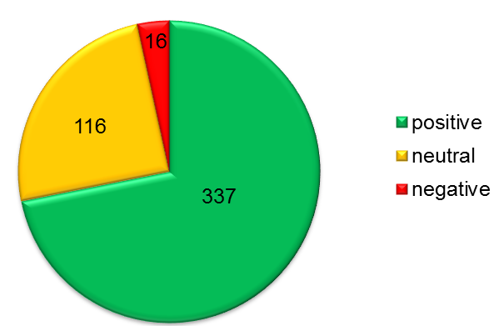
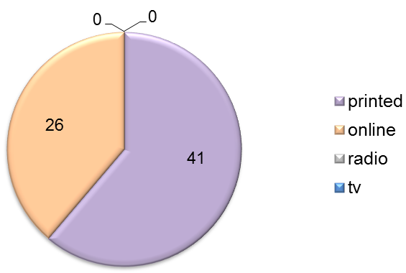

- 2 national publications
- 9 health or social care publications
- 55 local publications
Reach:

Summary of coverage:
- Trust shortlisted for awards Various local press. Trust shortlisted for two HSJ awards.
- Doctor and patient leads campaign Local press. Dr Kate Granger visits Trust. (link not available online).
- Charity unveils recovery room Local press. Mind, part of crisis care concordat, opens recovery room.
- Supporting the physical health of people with serious mental illness Health and social care blog. Insight into Kate Dale’s work.
- Students’ opinions will help hospitals improve Various local press. Your Future Your Health event at Bradford City football Club.
- Employees are the stars of this internal event National blog about how Comms Team do YASA.

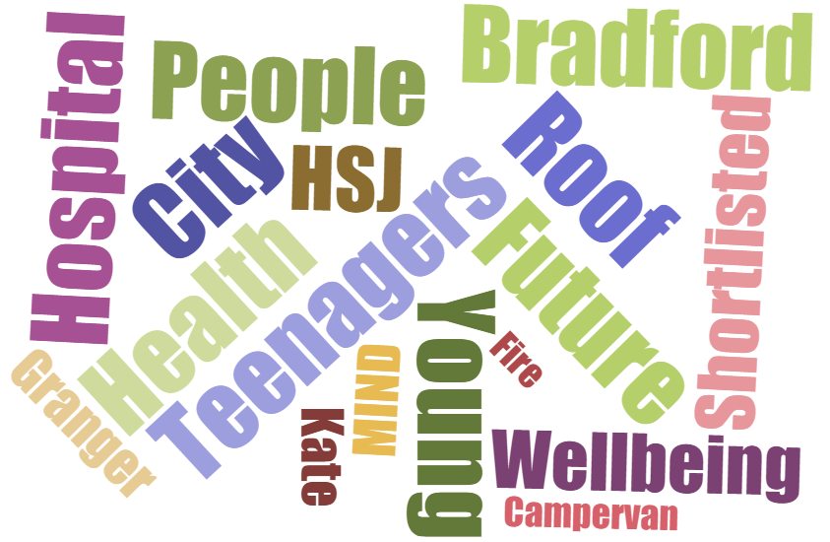
Key words:

Website
Twitter
Facebook
Social & Online Media:

www.bdct.nhs.uk
637
Page
Likes

21
BDCT Posts

141
Shares & Post Likes

9,588
Visits

4,466
Returning
Visits

01:55
Average Length of Visit

Last
Month
9,291
Last
Month
1,451
1,484
Followers

163
BDCT
Posts

298
Talking about us

Last
Month
613

Last
Month
3,334
Last
Month
158
Last
Month
13

Last
Month
02:06
Last
Month
367
Last
Month
132

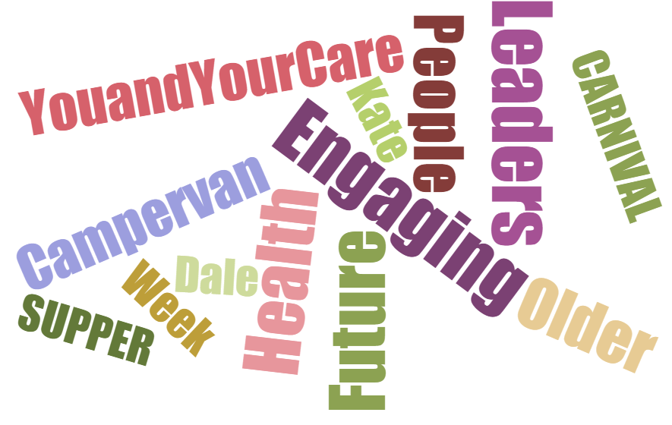
Key words:

Communications Team External Media Focus Quarter 3 (Oct- Dec 2015)
- Serious Case Review
- Board on the Road
- Board Recruitment

