BOARD MEETING

17 December 2015

Paper Title: Chief Executive’s Report
Section: Public
Lead Director: Simon Large, Chief Executive
Paper Author: Paul Hogg, Trust Secretary
Agenda Item: 7
Presented For: Discussion

1. Purpose of this Report:

The purpose of this report is to update Board members on national, regional and local issues, announcements relating to mental health, learning disability and community health services and Chief Executive level discussions within the local health economy.

2. Summary of Key Points

The key elements in this report are:

- Letter from Health Minister, Alastair Burt abut mental health funding;
- CQC visit to the Trust on 11 January 2016; and
- Further detail about the Comprehensive Spending Review.

3. Recommendation:

That the Board:

- Agrees to note the content of the report and identifies any other items that require further discussion at the Board meeting itself.

4. Financial Implications

None.

5. Legal Implications

None.

6. Equality Impact Assessment

Not applicable.

7. Previous Meetings/Committees Where the Report Has Been Considered:

Highlight whether the paper has been discussed at any of the following meetings by placing a tick in the relevant box(es):

Audit Committee |  | Quality & Safety Committee |  | Remuneration Committee |  | Finance Business & Investment Committee
Executive Management team | √ | Directors’ Meeting |  | Chair of Committees’ Meeting |  | MH Legislation Committee

8. Risk Issues Identified for Discussion

- Board members will want to identify any risks emerging from the content of the paper, and how new issues and challenges across the NHS might affect BDCFT. Any emerging issues may be taken forward through individual discussions with Directors outside Board meetings or suggesting a future paper to the Board or its Committees.

9. Publication under Freedom of Information Act

This paper has been made available under the Freedom of Information Act.

December 2015
Chief Executive’s Report

Local issues

CQC focussed inspection
The Trust has been informed that the CQC will be undertaking a focused inspection on 11 January 2016; this will take up to three days and will be conducted by a small team of approximately 3-4 people. Although further detail regarding the inspection process is awaited, the main purpose of this inspection is to review our progress against the two ‘must do’ (compliance) actions that the Trust had in place following the inspection in June 2014. These actions related to improvements to our Health Based Places of Safety and embedding the Continuous Care Medical Model. The CQC are also likely to look at some of the ‘should do’ actions from the previous inspection and any other current issues that they wish to review and they have indicated that they will look at the use of Section 17 leave in Low Secure Services and the admission of people under 18 to adult mental health wards. The safe domain could be rated as good (green) if CQC are assured by what they see during this inspection. The CQC are also considering whether they need to re-visit any of our community health services but stated that this is unlikely to be required. The Trust had already embarked on a piece of work to review a number of the ‘should do’ actions; this work will be completed in mid-December and the outcomes shared with the Executive Management Team.
National issues

Comprehensive spending review 2015
On 25 November, the government published its Comprehensive Spending Review, setting out the budget for each department over the course of this Parliament. There is still a substantial amount of detail yet to come about what the announcement means for the NHS, and the implications of the spending review for the 2016/17 national tariff, planning round, contracting round and commissioner allocations. However, key headlines for health include confirmation of an extra £10bn in real terms for the NHS by 2020.
Link: NHS investment

NHS Leaders Planning Event: Leeds Royal Armouries
Chief Executives were invited to attend an NHS Leaders Planning Event with presentations from Simon Stevens and Jim Mackey (NHS Improvement. This was followed by a panel Q&A session that also included Sir Andrew Dillon (NICE), Duncan Selbie (PHE) and David Behan (CQC).
It was clear that negotiation of the NHS settlement had been complex but that there was a clear expectation that organisations should now focus on 3 key priorities:
- Making the Money Work: the settlement is ‘U’ shaped, with lean middle years so early financial ‘grip’ is critical. This must include robust review of clinical variation (CCGs) and achievement of agency and efficiencies outlined by Lord Carter (Providers).
- Achievement of targets (Constitution standards RTT, A&E & Cancer).
- Service Re-design: doing more and faster
Headline expected Settlement impacts for the NHS England were outlined:
- Tariff Inflator of +1.06% (comprising efficiency of 2% and 3.06% inflation uplift) subject to Monitor Consultation and Monitor Board approval.
- £3.8bn uplift for 2016/17 will provide CCG/NHSE allocation uplifts but will also support deficit reduction.
- Public Health Grant reductions quoted are real terms reductions that equate to an average of 2.5% cash reduction.

It was acknowledged that Public Health and Social Care settlements were challenging but the panel saw the social care precept as truly ‘ground breaking’.
Simon Stevens summed up that success would be measured by:
- Improved cancer performance
- Mental Health including achievement of the new access targets
- Prevention including focus on obesity and diabetes prevention
- 7 Day Services with 3 separate issues each requiring a tailored response; Hospital Cover, Urgent & Emergency Care (Out of Hospital) and GP Out of Hours

The NHS England Board will consider CCG Allocations on 17 December with the expectation that these will be issued early the following week, alongside national planning guidance. CCG allocations will include 2 key changes; a place based aspect and a sparcity adjustment.
2016/17 planning activities will be in 2 stages:
- Organisational plans for 2016/17.
- Unit of Planning level 5 year plans to be developed by the summer.

The Trust’s Unit of Planning comprises all Bradford, Airedale, Wharfedale and Craven CCGs and Provider FTs.
Letter from Health Minister on mental health funding
Alistair Burt, Minister of State for Community and Social Care has written to NHS England and Monitor in support of mental health funding and the expectations on CCGs about the increase in mental health funding as a proportion of overall health spending. The letter goes on to encourage continued focus from CCGs and MH providers around:
- Local Crisis Concordat plans;
- Improving CAMHS services linked to new performance data requirements;
- New access and waiting times standards; and
- Data on eating disorders of young people to be collected through MHSDS.
A copy of the letter has been included with the Board papers pack.
CQC Proposals for fees increase from April 2016
The CQC are proposing to increase their annual fee that providers pay for the services. The Health and Social Care Act 2008 includes powers for the CQC to set regulatory fees, subject to consultation, approval by CQC Board and the Secretary of State’s approval of the recommendations. The fee scheme cannot take effect until he has consented to it.
CQC is funded through both grant-in-aid from the Department of Health and fee income. Government policy is to set fees that cover chargeable costs, and in doing so reduce reliance on grant-in-aid. The CQC have to take account of that obligation when developing consultation proposals.
This consultation document sets out the proposals in relation to fees for the 2016/17 fee scheme and also about their intention for fee increases over future years. It is proposed to increase the fee for a Trust of our size by 270% over the next few years. Providers have until 16th January to respond to the consultation. The northern Mental Health Trusts are planning a joint response.
Link: CQC Fees Consultation Document
NSPCC encourages children and teenagers to share their care experiences
The Care Quality Commission (CQC) has launched a six-month partnership with the NSPCC and its free, 24-hour counselling service, ChildLine. This latest 'tell us about your care' partnership is one of seven projects underway with national organisations that are in a unique position to reach, and be reached by, people who may choose to discuss concerns about the way they are receiving health and adult social care or to identify examples of best practice. The feedback received acts as vital intelligence to help inform where, when and what the CQC inspects.
Link: Sharing care experiences

BDCT External Media Report November 2015 (01.11.15 – 30.11.15)
This report has been put together by the Trust’s Communications Team. All figures provided are true figures (not percentages). Further data and analysis is available upon request. Clippings, sound bites, and videos are available in the communications office, room 2.10, New Mill.
Print & Broadcast Media:
Unique hits this month: 53

Coverage by tone, year to date, and type for this month:

- 3 national publications
- 3 health or social care publications
- 47 local publications
Reach:

Summary of coverage:
- Mayor pays visit to dementia unit. Local press. Link not available online
- Bradford district nurse scoops national Queens Nurse Award
- and patient leads campaign. Various local press.
- Volunteers at the heart of caring. Various local press. Story about volunteer strategy and how volunteers make a difference. Link not available online
- History celebrated by Trust. Trust mark culmination of Black History Month with celebration. Various local press.
- Should psychiatric hospitals completely ban smoking? British Medical Journal. Article debates the pros and cons. Link not available online
- 'Rich list' reveals top NHS earners. Local press.
- Young given tips on mental health. Local press. Guide to help teenagers deal with worries of life as they enter adulthood. Link not available online
- Learning to cope without alcohol. Local press. Team helps people deal with drink issues. Link not available online
- Assault figures on staff. Local press. Press angle: violence on staff unacceptable.

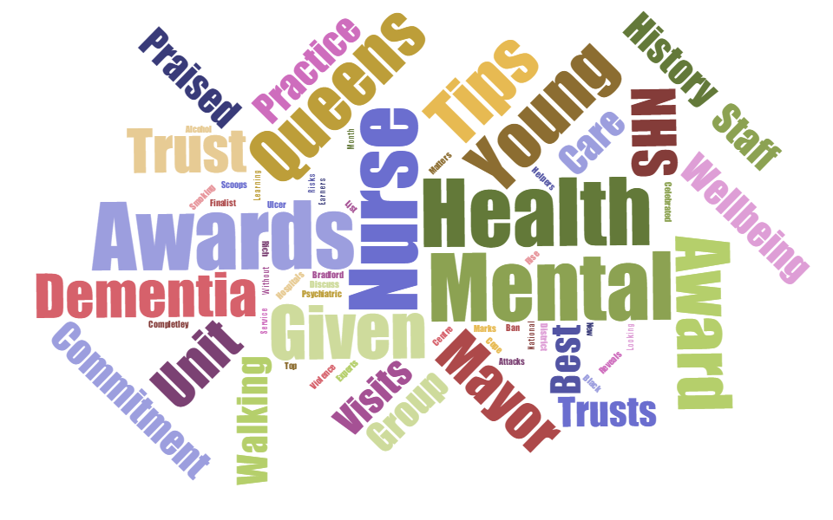
Key words:

Website
Twitter
Facebook
Social & Online Media:

www.bdct.nhs.uk
674
Page
Likes

21
BDCT Posts

354
Shares & Post Likes

10,999
Visits

5132
Returning
Visits

01:51
Average Length of Visit

Last
Month
9,588
Last
Month
1,484
1,515
Followers

145
BDCT
Posts

128
Talking about us

Last
Month
637

Last
Month
4,466
Last
Month
163
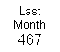
Last
Month
21

Last
Month
01:51
Last
Month
298
Last
Month
141

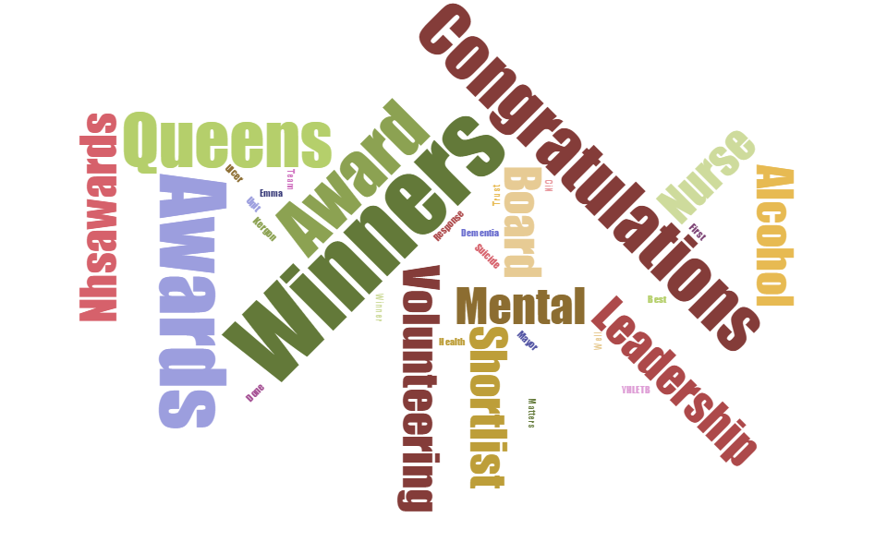
Key words:

Communications Team External Media Focus Quarter 3 (Oct- Dec 2015)
CSE Case
Awards Celebrations
Non-Executive Director Recruitment
Annual Plan Preparations

