BOARD MEETING

25 February 2016

Paper Title: Chief Executive’s Report
Section: Public
Lead Director: Simon Large, Chief Executive
Paper Author: Paul Hogg, Trust Secretary
Agenda Item: 7
Presented For: Discussion

1. Purpose of this Report:

The purpose of this report is to update Board members on national, regional and local issues, announcements relating to mental health, learning disability and community health services and Chief Executive level discussions within the local health economy.

2. Summary of Key Points

There are a number of significant reports that have been published recently and the Board may wish to focus on one of more of the following:

- 5 Year Forward View for Mental Health - Taskforce Report
- Carter Review
- Lord Crisp Commission

3. Recommendation:

That the Board:

- Agrees to note the content of the report and identifies any other items that require further discussion at the Board meeting itself.

4. Financial Implications

None.

5. Legal Implications

None.

6. Equality Impact Assessment

Not applicable.

7. Previous Meetings/Committees Where the Report Has Been Considered:

Highlight whether the paper has been discussed at any of the following meetings by placing a tick in the relevant box(es):

Audit Committee |  | Quality & Safety Committee |  | Remuneration Committee |  | Finance Business & Investment Committee
Executive Management team | √ | Directors’ Meeting |  | Chair of Committees’ Meeting |  | MH Legislation Committee

8. Risk Issues Identified for Discussion

- Board members will want to identify any risks emerging from the content of the paper, and how new issues and challenges across the NHS might affect BDCFT. Any emerging issues may be taken forward through individual discussions with Directors outside Board meetings or suggesting a future paper to the Board or its Committees.

9. Publication under Freedom of Information Act

This paper has been made available under the Freedom of Information Act.

February 2016
Chief Executive’s Report

Local issues

BDCFT services featured in national Taskforce Report on mental health
The Trust is featured as one of the national examples of best practice, linking our First Response service to one of the key priority actions within the report around providing access to mental health care 24/7. A film about the First Response service was used as part of the launch of the report (see further details below).

Link: First Response film used in Taskforce Report

Time to Talk Day – 4 February 2016
The Trust led the local conversation to support the national Time to Talk Day, to encourage people to talk about mental health in the media, on-line, at home and at local events. Activity included traditional and social media, including a twitter chat fronted by mental health nurse, Kayleigh Abbott, and news posts in partner channels (CCG and our PPI e-bulletins). Supporting material, including personal stories / films of people talking about their mental health, presence outside a local supermarket and 10 top tips on helping people with a mental health problem, which strengthened the story and ensured good coverage for the Trust on the day. The activity achieved:
- Coverage across our core media - Calendar, Pulse, BCB radio, T&A, Keighley News, Ilkley Gazette and Craven Herald, featuring interviews with our staff, reaching around 152,340 people.
- Social media activity significantly extended our reach - supportive re-tweets included NHS England North (13.1k followers), West Yorkshire Police (16.4K followers), Healthwatch Bradford (1.5K followers), Councillor Ralph Berry (3K followers), NHS Employers (30.3K followers) and Sainsbury’s - linked to our community event - (50.1K followers).

Flu Figures

The Trust’s final flu vaccination uptake figure was 77.3%, which is above the Department of Health target of 75% and further national benchmarking for all Trusts will be published shortly. Figures published up until the end of December showed BDCFT as the highest performing mental health or community Trust in the country.

Link: Vaccination figures

Zero Suicide Event

On 8 February, the West Yorkshire Vanguard held a Zero Suicide Event at Bradford City Football Ground. An internationally acknowledged expert on developing the “Zero Approach” to Suicide Prevention, David Covington, from the USA was amongst the guest speakers, along with Professor Nav Kapur, from the Centre for Suicide Prevention, Manchester University. Dr Mike Doyle from South West Yorkshire Partnership NHS Foundation Trust also contributed giving a West Yorkshire perspective and Dr Rebeca Martinez shared Mersey Care NHS Trust’s experience of using the “Zero Approach” in the UK.

Over 160 people attended the event with delegates from a range of NHS Trusts across West Yorkshire, West Yorkshire Police, West Yorkshire Fire and Rescue, Yorkshire Ambulance Services, Local Authorities, Universities and Voluntary agencies. The event shared good practice within all agencies and discussed gaps and solutions in reducing suicides across West Yorkshire.

National issues

5 Year Forward View for Mental Health - Taskforce Report
The 5 Year Forward View for Mental Health was published on 15 February 2016. This national strategy, which covers care and support for all ages, signifies the first time there has been a strategic approach to improving mental health outcomes across the health and care system, in partnership with the health arm’s length bodies. The report sets out recommendations for the six NHS arm’s length bodies to achieve the ambition of parity of esteem between mental and physical health and wider action on tackling health inequalities. Priority actions for the NHS by 2020/21 include:
- access to mental health care 7 days a week and 24 hours a day in the same way that they are able to get access to urgent physical health care;
- mental health out of area placements for acute care to be reduced and eliminated as quickly as possible;
- people experiencing a first episode of psychosis to have access to a NICE-approved care package within 2 weeks of referral;
- implement a major drive to reduce suicide by 10 per cent by 2020/21;
- support more women each year to access evidence-based specialist mental health care during the perinatal period;
- increase access to evidence-based psychological therapies;
- greater access to high-quality mental health care for young people; and
- more support for people living with mental health problems to find or stay in work.

Link: MH Taskforce Report

Lord Crisp Commission

The Independent Commission was set up in 2015 to address the issues facing patients in England needing acute care for mental health problems. Current estimates suggest that around 500 mentally ill people have to travel over 50km to be admitted into hospital every month. These long distance admissions are mainly due to difficulties in finding acute inpatient beds or suitable alternative services in their home area. The Commission’s report recommended significant changes to how mental health services are commissioned, organised and monitored across the whole mental health system. Key recommendations from the report include:

- the introduction by October 2017 of a maximum waiting time of four hours for admission to an acute psychiatric ward for adults or acceptance for home based treatment following assessment;
- phasing out nationally the practice of sending acutely ill patients long distances for non-specialist treatment by October 2017;
- more investment in home-based treatment, information systems and staff; and
- that patients and carers are enabled to play a greater role in their own care as well as in service design, provision, monitoring and governance.

Raising Concerns /Whistleblowing / Freedom to Speak Up Guardians

The national Freedom to Speak Up (FTSU) Guardian, Dame Eileen Sills OBE, was appointed in January 2016 following the end of the national consultation published by Monitor, the Trust Development Authority and NHS England on a draft single national whistleblowing policy. The role of national guardian was one of the key elements of the proposed approach. One of Dame Sills’ early priorities will be to develop guidance on the role of local guardians.

The Trust’s current policy already meets the suggested standards set out in the proposed policy although it will require revisiting when the final, national policy is released. All Trusts are expected to appoint local guardians. An options paper will be developed and discussed at the Executive Management Team with a recommendation being brought to the Board for discussion and final approval.

Carter Review

Lord Carter's review of efficiency in hospitals looked at productivity and efficiency in English non-specialist acute hospitals, which account for half of the total health budget, using a series of metrics and benchmarks to enable comparison. The reports concludes that there is significant unwarranted variation across all of the main resource areas, estimated to be worth £5bn in terms of efficiency opportunity – a potential contribution of at least 9% on the £55.6bn spent by our acute hospitals. The report makes 15 recommendations designed to tackle this variation and help trusts improve their performance to match the best examples within the sector.

It is clear that most of the focus from this review is directed at Acute Trusts. However there will be areas where BDCFT can consider efficiency in relation to the benchmark of reference costs used in this report. We will consider this as part of the annual planning process and specifically through our Procurement Group. More generally the Airedale Supplies/Procurement Team will be working on the review recommendations.

Link: Carter Review - Executive Summary and Full Report

Developing Sustainability and Transformation Plans (STP)
The NHS Arm’s Length bodies have sent a collective letter to NHS commissioners and providers setting out the initial thinking on STPs, the foundation stone of NHS planning for the implementation of the 5 year forward view. STPs will be place-based multi-year plans built around the needs of the local populations. The letter sets out initial guidance and a planning timetable for the development of STPs by June 2016. The letter also sets out how sustainability and transformation funding can be accessed as part of the STP development and delivery.

Link: Sustainability and Transformation Plan Letter 16 February 2016.pdf

…comment

Both the Taskforce and the Commission reports are a welcome focus on improving mental health services; they have been widely consultative and carefully thought through in the presentation of the recommendations. The Government’s initial response is supportive and reflective of a national need for greater investment and improved access, uptake and availability of services. The inevitable assumption is that additional monies are in the NHS uplift and allocations to CCGs and are not ring-fenced. Given the front loading of the allocations and focus on financial balance and sustainability we will need to build any expectations into the current negotiations for the 2016/17 contracts.
BDCT External Media Report January 2016 (01.01.16 – 31.01.16)
This report has been put together by the Trust’s Communications Team. All figures provided are true figures (not percentages). Further data and analysis is available upon request. Clippings, sound bites, and videos are available in the communications office, room 2.10, New Mill.
Print & Broadcast Media:
Media Coverage achieved in January
Sentiment of overall coverage from April 2015 – Jan 2016
- 2 national publications
- 1 health or social care publications
- 39 local publications
Summary of coverage:

- Tribute to Healthcare Hero’s. Various local press.
Reach:
- Cash boost to teaching hospitals. Various local press. Story about our cash donation from Sovereign Health Care. Link not available online.
- Glowing feedback for trust. Various Local press. Story about the Trusts excellent feedback from the Friends and Family Test results in November. Link not available.
- Father-of-two in rail track tragedy. Various local press. Story about a father with mental health problems who died on the Leeds-Skipton line in September last year. The inquest heard he had been supported by Bradford District Care NHS Foundation Trust.
- Support for mental health illness. Various local press - Story about a new project that aims to improve the quality of care received by local people with mental health issues.
- #NHSWhereIstarted. National publication. Story about who got involved in the #NHSwhereIstarted campaign.

Key words in the press:

Social & Online Media:
Website
Twitter
Facebook
www.bdct.nhs.uk
12,485
Visits

6053
Returning
Visits

02:41
Average Length of Visit

717
Page
Likes

12
BDCT Posts

67
Shares & Post Likes

Last
Month
10,272
Last
Month
1,540
1,571
Followers

127
BDCT
Posts

174
Talking about us

Last
Month
692

Last
Month
4771
Last
Month
121
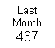
Last
Month
20

Last
Month
02:07
Last
Month
75
Last
Month
133

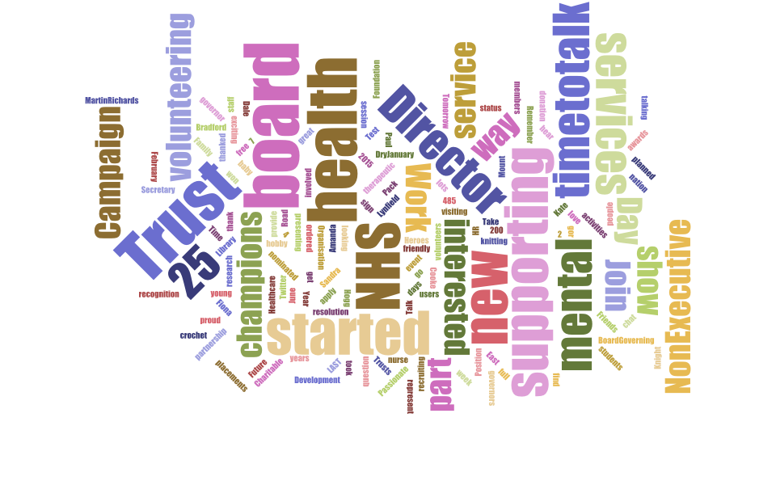
Key words on social media:
Communications Team External Media Focus
Quarter 4 (January – March 2016)

• Time to Talk (4 Feb)
• Zero suicide conference (8 Feb)
• Staff survey results (23 Feb)
• Carers hub launch (18 March)
• Board on the Road meetings (on-going)
• Annual plan preparations (on going)

